CHECKOUT INVENTORY PREPARED FOR

FLAT 12 FRANCIS HOUSE

BRENTFORD

TW8 0HL

5TH SEPTEMBER 2019 / 04TH MAY 2021

**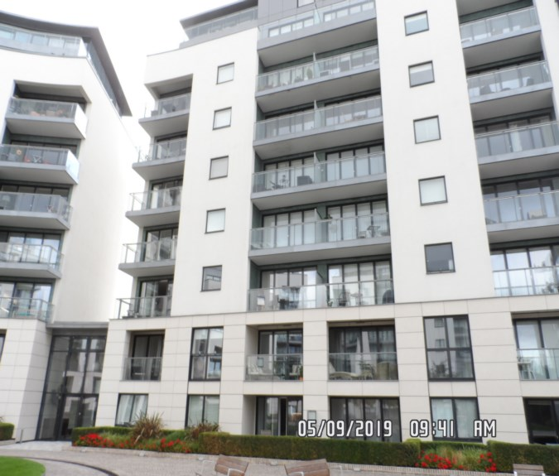**

|  |  |
| --- | --- |
| **CLIENT:** | Thorgills |
| **INSTRUCTED BY:** | Amy Love |
| **TENANT:** | Harry Mullins, Alfie Nolan |
| **REF:** | MBPS-002 / MBPS-002 |
| **INSPECTED BY:** | Gary Krienkie |
| **PROPERTY SIZE:** | 1 Reception/ 2 Bedrooms/ 2 Bathrooms / 1 Utility / 1 Store Room / 1 Balcony – Furnished Flat |

'WINDY RIDGE' [99 COWLEY HILL, BOREHAMWOOD, HERTS, WD6 5NA](https://maps.google.com/?q=99+COWLEY+HILL,+BOREHAMWOOD,+HERTS,+WD6+5NA&entry=gmail&source=g),    TEL: 020 8 386 0950 - MOBILE: 077 67 647 647  
EMAIL: [info@inventorys.net](mailto:info@inventorys.net)   [www.inventorys.net](http://www.inventorys.net/)  
Registered No: 4263261 VAT No: 822 9322 12

Safety Disclaimer

This inventory report is prepared as an ‘as seen snapshot’ of the property and its contents at the time of the designated inspection and is compiled as a fair and accurate record for the properties internal condition and contents. This does not form any part of a valuation or structural report.

This inventory is compiled on the basis that all items listed are in good order and clean. Any defects or soiling are noted where appropriate. Where inspections are carried out and the tenants’ belongings are in situ, it can be difficult for clerks to differentiate to that belonging to the landlord or tenant. Should the report contain inaccuracies the clerk (Independent Inventories (UK) Ltd) will not be held responsible.

The clerk preparing the inventory is not an expert in electrical appliances, antiques, furniture style, fabrics, flooring, etc. All descriptions within this report are for identification purposes only in order that each item can be compared to its condition at the commencement of the tenancy.

Lofts and Cellars are not included unless they are converted and safely accessible. Contents will therefore not be noted or checked at check in or checkout.

Plants and shrubs will not be itemised.

Belongings left by the landlord/agent in a locked room or outbuilding will not be inventoried and are the sole responsibility of the Landlord/agent. Items in garages/sheds such as garden equipment and tools will be inventoried, however tins of paint will not be itemised.

We do not undertake to move heavy items of furniture or access lofts, high-level cupboards, or any other inaccessible places. Contents which have been left in the above-mentioned areas, which have not been inventoried, are the sole responsibility on the landlord. We also do not undertake to open windows, but will confirm whether keys have been seen or not.

Any electrical appliances tested will be for power only and only where practicable. The clerks are not qualified electricians and will only confirm the visual condition of the electrical socket, wiring and or fitting as seen. Boilers, Heating Systems, Gas Fires, Water Supply and Radiators are not tested, and Independent Inventories (UK) Ltd will not take any responsibility for units left either on or off even if on automatic timers. Where smoke alarms and CO Detectors are tested this is for power only and should not be taken to mean that the alarms are in full working order. We only state their presence and cannot state the functioning of this equipment. No responsibility is taken for any damage or malfunction occurring during the testing of such alarms.

The relevant utility companies must check all meter readings, as we cannot be held responsible for any discrepancies. We are not held liable should meters not be located or inaccessible to read. For Health and Safety reasons we do not expect our clerks to access high level areas which involve using ladders/chairs.

The Fire & safety Regulations regarding furnishings, gas, electrical & similar services are ultimately the responsibility of the instructing principle. Where the inventory notes FFR label seen, this should not be interpreted to mean that the item complies with the furniture & furnishings (fire) (safety) (Amendments) 1993. It is a record that the item had a label as described or similar to that detailed in the Guide to the regulations as published by the Department of Trade & Industry, January 1997, (or subsequent edition), attached at the time the inventory was complied.

Blinds in the premises are visually checked. We are unable to verify that the blinds comply with child safety requirements of BS EN 131202009 + A1:2014 placed on the manufacturer, supplier and professional installation of internal window blinds

It is the responsibility of the landlord/managing agent/tenant to agree between themselves the accuracy of the report, and Independent Inventories (UK) Ltd should be notified within 7 days of receipt of the report of any discrepancies within the report.

GENERAL GUIDANCE NOTES

Independent Inventories do not have site of tenancy agreements or other agreements made between the tenant, landlord and management company. As these are guidance notes only it is always advisable that the tenancy agreement is cross referenced. This report will indicate whether in our opinion the tenant is liable for the deterioration or whether it is considered fair wear & tear. Independent Inventories may suggest maintenance, cleaning or tenant’s liability at checkout, but the final responsibility of these suggestions will fall with the landlord or managing agent in respect of the original tenancy agreement. We do not suggest costs of any items, these should be sourced from the relevant contractors by the landlord or managing agent.

CLEANING

We recommend that a professional cleaning company is employed at the end of the tenancy, unless alternative arrangements have been agreed with the Landlord/Managing Agent. Receipts from professional cleaning and carpet cleaning companies must be present to the clerk at the checkout inspection.

If the standard of cleaning is not satisfactory most Landlords/Managing Agents will contract a cleaner and their charges will be charged to the tenant unless otherwise stated in the tenancy agreement.

DECORATION

It is accepted that during the course of the day to day living scuffs will appear on walls and woodwork. However, should the marks be found to be excessive charges will be made to you the tenant, unless otherwise stated in the tenancy agreement.

LIGHTING

If the lights are working at check in then it is normal, if lights are not working at checkout, for these to be the responsibility of the tenant to replace bulbs or to be charged accordingly, unless otherwise stated in the tenancy agreement.

GARDENS/PATIO

If the standard of the garden/patio is found to be untidy compared to the start of the tenancy the Landlord/Managing Agent are entitled to employ a contract gardener and the charge will be made to you the tenant, unless otherwise stated in the tenancy agreement.

MAINTENANCE ISSUES

We recommended should any maintenance issues arise you contact the Landlord/Managing Agent immediately so they can deal with the matter. Should we recommend items require maintenance once a property has been checked out, this is purely stating that an item will require fixing/attention, we are not advising as to whose responsibility this and your tenancy agreement will need to be checked.

CHANGES TO PROPERTY

We recommend that if you wish to make any changes to the décor or remove any of the Landlords belongings you contact the Landlord/Managing Agent for permission and have this confirmed in writing to ensure there are no discrepancies at the end of the tenancy.

TENANTS INFORMATION FOR CHECKING OUT OF PROPERTY

It is important at the checkout that:

1. All cleaning should be completed prior to the checkout appointment as per the tenancy agreement.
2. All personal items must be removed prior to the check out.
3. All items should be in the same location as per the inventory, any stored items should be unpacked and also returned to the same location.
4. If the Inventory clerk has to search for items or you still have belongings in the property to be removed this will result in additional charges being made to the tenant.
5. All beds should be left unmade with the linen folded. Bedding & towels should be cleaned & ironed where relevant.
6. All food items should be removed, freezers defrosted & doors left open & electricity turned off.
7. All light bulbs etc. should all be in working order as at check in.

The property should be left in a clean and tidy condition especially carpets, curtains, windows, upholstery appliances etc. We would suggest that you refer to your tenancy agreement in this matter.

If you are not ready to leave it may not be possible to carry out the checkout. In this case a return visit will be necessary resulting in a cancellation charge.

All keys to the property must be handed over at the time of checking out to the Inventory clerk or alternatively to the agents prior to the check out taking place.

The Inventory Clerk acts as an independent and reasonable body and will avoid unnecessary criticism or derogatory comments when compiling or checking the Inventory.

At the termination of the tenancy the inventory will be checked and any obvious or significant discrepancies will be reported to the Managing Agent/Instructing Principal. This report will indicate whether in our opinion the tenant is liable for the deterioration or whether it is considered fair wear & tear. Normal fair wear and tear will be assessed on the lengthy of the tenancy and type occupancy.

INDEX

PAGE

|  |  |
| --- | --- |
| UTILITY READING | 2-3 |
|  |  |
| KEYS | 4 |
|  |  |
| GENERAL SUMMARY | 5 |
|  |  |
| INSTRUCTION MANUALS | 6 |
|  |  |
| CLEANING RECEIPT | 7 |
|  |  |
| ENTRANCE HALLWAY | 8-17 |
|  |  |
| BEDROOM 1 | 18-23 |
|  |  |
| BEDROOM 2 | 24-29 |
|  |  |
| ENSUITE | 30-35 |
|  |  |
| BATHROOM | 36-41 |
|  |  |
| RECEPTION | 42-47 |
|  |  |
| KITCHEN | 48-55 |
|  |  |
| TERRACE | 56-57 |
|  |  |
| SIGNED SCHEDULE OF CONDITION AT CHECKIN | 58-63 |
|  |  |
| SIGNED SCHEDULE OF CONDITION AT CHECKOUT |  |

**UTILITY READINGS / KEY LIST& INSTRUCTION MANUALS**

|  |  |  |
| --- | --- | --- |
| **ELECTRIC** | **GAS** | **WATER** |
| METER NUMBER:  13K0122950 | METER NUMBER: | METER NUMBER:  14506147 |
| READING:  14597.9 | READING: | READING:  222.75 |
| LOCATION:  Utility room | LOCATION: | LOCATION:  Utility room |

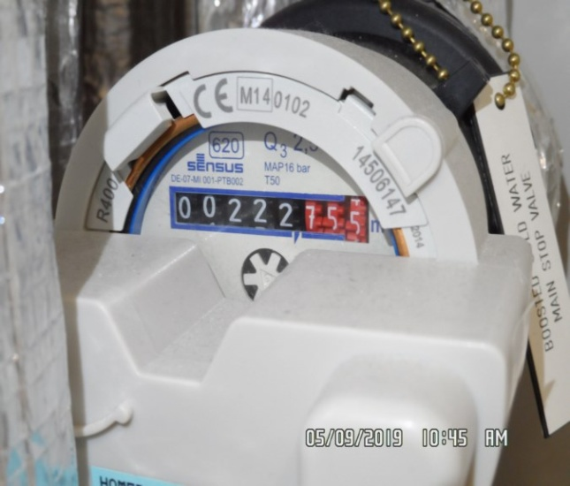 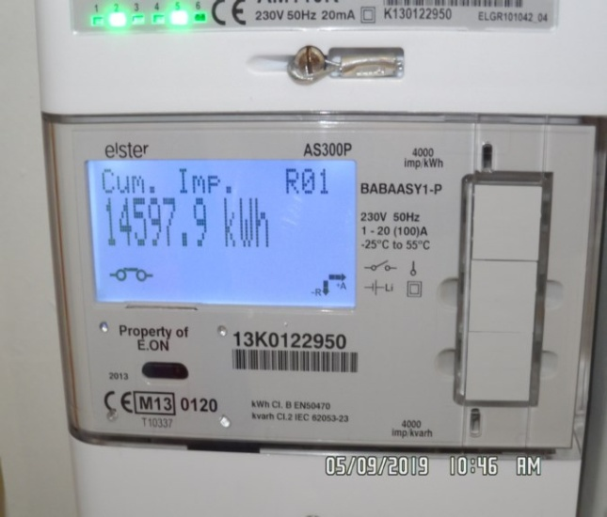

|  |  |  |
| --- | --- | --- |
| **ELECTRIC** | **GAS** | **WATER** |
| METER NUMBER:  13K0122950 | METER NUMBER: | METER NUMBER:  14506147 |
| READING:  26661.1 | READING: | READING:  00473.643 |
| LOCATION:  Utility room | LOCATION: | LOCATION:  Utility room |

|  |
| --- |
| **FIRE SAFETY** |

|  |  |
| --- | --- |
| **SMOKE ALARM 1** | Power light on  Tested with canned smoke and working order  Location: Hallway |
| **SMOKE ALARM 2** | Power light on  Tested with canned smoke and working order  Location: Kitchen |
| **CARBON MONOXIDE ALARM** | N/A |

|  |
| --- |
| **LOCATION OF:** |

|  |  |  |
| --- | --- | --- |
| **STOP COCK** | Utility room | |
| **FUSE BOARD** | Utility room | |
| **ALARM PANEL**  **This has not been tested** | None | MAKE: |

|  |  |
| --- | --- |
| **KEYS AT CHECKIN** | **KEYS AT CHECKOUT** |
| **KEY TYPE / SERIAL NUMBER / QTY** | **KEY TYPE / SERIAL NUMBER / QTY** |
| 1 X Silver Yale |  |
| 1 X Window Key (Velfac) |  |
| 1 X Grey Fob Keri (N2663.835681) |  |
|  |  |
|  |  |
|  |  |
| **KEYS RECEIVED BY: Concierge (Anyonio)**  \\Pc-1\mbps\II\6TH SEPT\6TH SEPT\12 FRANCIS HOUSE - IN\Pictures\New folder\SAM_1743 (Copy).JPG | **KEYS RETURNED TO: Picked up and dropped off at Thorgills, picture of keys taken \*\*\*** |

 \*N.B – Heavy items will not be moved or inspected behind/under, for health & safety reasons. We will not be held liable should any damages/stains/marks be found during the tenancy in these areas. Should the occupant find any of the above they should, inform the landlord/agent immediately and if/where possible take photographic evidence and pass to the relevant parties.

|  |
| --- |
| **GENERAL SUMMARY** |

|  |  |  |
| --- | --- | --- |
| **ITEM** | **CHECKIN NOTES** | **CHECKOUT NOTES** |

|  |  |  |  |
| --- | --- | --- | --- |
| **GENERAL CONDITION** | | Further general cleaning required  In use | Domestically cleaned for the end of tenancy  Further general cleaning required |
| **ODOUR** | | N/A | N/A |
| **DECORATIVE ORDER / WOODWORK** | | Good order  Defects as noted  Woodwork scuffed/chipped | Defects as noted  Woodwork scuffed/chipped |
| **FLOORING** | | Good order  Defects as noted  In use | Defects noted  Further cleaning required |
| **CURTAINS / BLINDS** | | Defects as noted  Good order | Defects noted |
| **BLIND REGULATIONS** | | Chain break connector in place  Chain tidy in place |  |
| **UPHOLSTERY** | | New  Defects as noted  In use | Defects noted |
| **FFR LABELS** | Sofa FFR labels seen  Mattress bedroom 1 FFR labels seen  Mattress bedroom 2 FFR labels seen | |  |
| **LINEN** | None provided | | None provided |
| **LIGHTS** | All working order | | All working order |
| **KITCHEN / APPLIANCES** | All appliances power tested  Fridge/ freezer left shut power on  In use | | All appliances power tested  Fridge/ freezer left shut power on  Requires further cleaning |
| **BATHROOMS/**  **WC** | Water outlets tested and working  In use | | Water outlets tested and working  Mildew to areas as noted  Requires further cleaning |
| **WINDOWS** | Fitments complete  Clean to interior | | Fitments complete  Clean to interior  Requires further cleaning |
| **GARDEN** | Seasonal order | | Seasonal order |

|  |  |
| --- | --- |
| **MANUALS SUPPLIED AT**  **CHECKIN** | **MANUALS RETURNED AT**  **CHECKOUT** |
| **APPLIANCE / MAKE** | **APPLIANCE/MAKE** |
| washing machine  fridge/ freezer  extractor hood  hob  oven  microwave oven  dishwasher |  |



**ENTRANCE HALLWAY**

|  |  |  |  |
| --- | --- | --- | --- |
| **Entrance Door** | Painted white door and frame  Fixed glass panel with integrated light fitting to right hand side with no 12 in black and white  Chrome twist handle  Chrome lock  Chrome letterbox and flap  Chrome spy hole | Small scratch marks to the mid level of the frame right hand side near the key area  Light fitting in good order, showing power  Plastic panel to the side in good order  Scratch marks to the left hand side mid level of the door  Further scratch marks and rub marks above the letterbox  Few minor chips to the bottom edge of the door  3 or 4 scratch marks behind the handle  5 x grey marks to the centre of the door  1 x black plastic hook seen to exterior door  Frame further light scuffing seen both left- and right-hand side low level  Operating lock from exterior door stiff  Door creaky  Hairline cracks or chips seen to the bottom of exterior door o |  |

**ENTRANCE HALLWAY**

|  |  |  |  |
| --- | --- | --- | --- |
| **Interior door** | Wood painted white door and frame  Chrome spy hole  Chrome chain  Chrome twist handle  Chrome lock  Chrome letterbox and flap | All in good condition  Twist lock stiff when operating  Interior frame appears to be intact  Interior door 1 or 2 x light scuff marks at low level |  |
| **Walls** | Painted butter-white | Left hand side low level some plaster filler seen  1 x adhesive pad seen to rear facing wall at high level  Front facing wall grey paint seen to the wall at high level  1 or 2 x light scuffs seen to walls at mid to low level  Rear facing wall some scuffing above entrance door  Some light scuffing rear facing wall low level |  |
| **Ceiling** | Painted white | Good condition  Large black scuff from smoke alarm to entrance frame |  |
| **Lighting** | 3 x recessed spot lights | Showing power  All tested for power |  |

**ENTRANCE HALLWAY**

|  |  |  |  |
| --- | --- | --- | --- |
| **Smoke alarm** | White plastic | Tested for power  Green light showing  Expiration date is October 2025 |  |
| **Switches and sockets** | White plastic | Good condition  Not tested  Intact  Light dust build-up seen around the edges |  |
| **Intercom** | Comelit digital display and touch button screen with mic | Showing power |  |
| **Woodwork** | Painted white | Good condition  1 or 2 x light scuff marks and rub marks seen  1 or 2 x chips seen to the corner edges at an angle |  |
| **Flooring** | White wood | Light used condition  Drag marks upon entrance  Further light scratches seen to the floor  Vacuumed for start of tenancy  Currently in use |  |

**ENTRANCE HALLWAY**

|  |  |  |  |
| --- | --- | --- | --- |
| **Cupboard 1 - left hand side** | Painted white  Chrome twist handle  Interior:  Painted white  Chrome twist handle  1 x shelf  1 x chrome rail  Walls and ceiling painted white  Skirting painted white  Floor continuation of the hallway  1 x integrated light with sensor mechanism  1 x clothes airier | Small black mark right hand side of exterior door frame  Small chip marks to the facing wall low level  1 or 2 small rubs scattered  Showing power, tested and working  Further light scratches to rear of handle  Interior door 1 x chip seen right hand side mid level  Walls heavy scuffing seen mid to low level to front and right hand side wall  Further chipping seen to the corner edges at an angle  Dust build-up to hat shelf  Light tested and working  1 x scratch seen high level exterior door  Clothes airier intact and in good order |  |

**ENTRANCE HALLWAY**

|  |  |  |  |
| --- | --- | --- | --- |
| **Cupboard 2** | 2 x double doors painted white  Chrome handle  White painted frame  Hinges to the exterior  Chrome lock to the interior edge of the door  White plastic light sensor  Interior:  Integrated spot light  Ceiling panelled  Walls painted white  Skirting painted white  White tiles with white grout  Water cut off valve to right hand side  Stop valves  Water meter  Mega flow white metal circular cylindrical water tank with pipe work and wires  White plastic fuse box with flip lid and wiring with electric meter to low level  Associated fuses and switches  Thermostatic control white plastic with digital display  BT open reach broadband white plastic with plug  Plumbing to low level | Painted over defects to the walls, doors and skirting  Floor in good condition  Light tested and working  Black scuffing seen to the underside of crossbar  Interior door left hand side some light black scuffing in places  Walls heavy scuffing seen to front facing wall  Dust build-up at mid level  Some light scuffing at mid to low level  Showing power  Showing power  Showing power  Showing power  Showing power  Ceiling appears to be intact  Skirting some light dust build-up seen  Interior door left hand side high level finger soil marks seen |  |

**ENTRANCE HALLWAY**

|  |  |  |  |
| --- | --- | --- | --- |
| **Cupboard 2 contd..,** |  | Flooring discolouration seen to grout  Some light debris in places  Hot water tank not tested  Appears to be intact  Fuse box, electric meter and water meter all intact  1 x washer and dryer soap tray some light discolouration  Sealant some mould residue in places  Washing machine tested for power |  |
| **Door stop** | Chrome and black rubber skirting mounted | Good condition |  |

Entrance and hallway Entrance and hallway

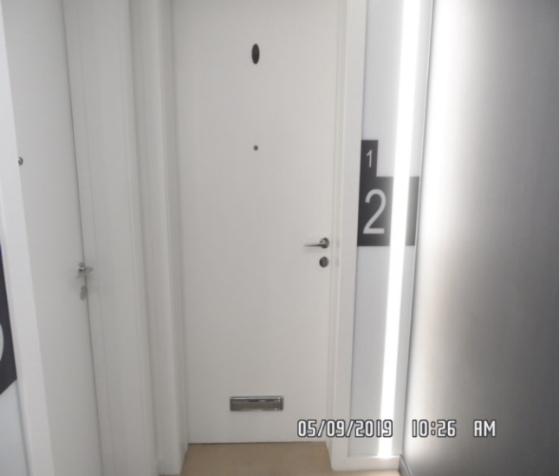 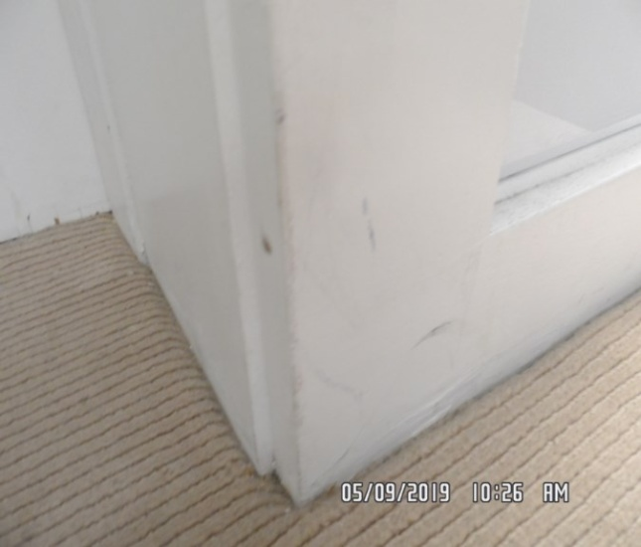

Entrance and hallway Entrance and hallway

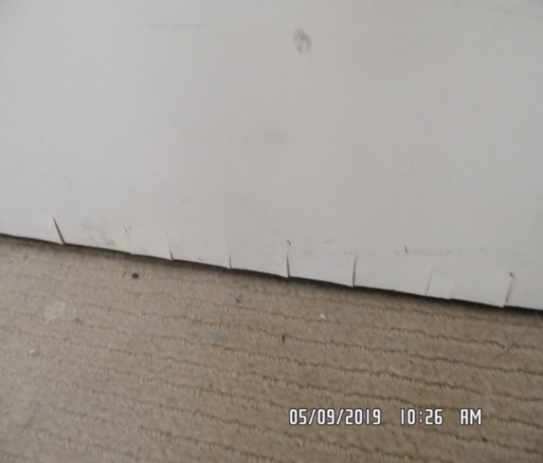 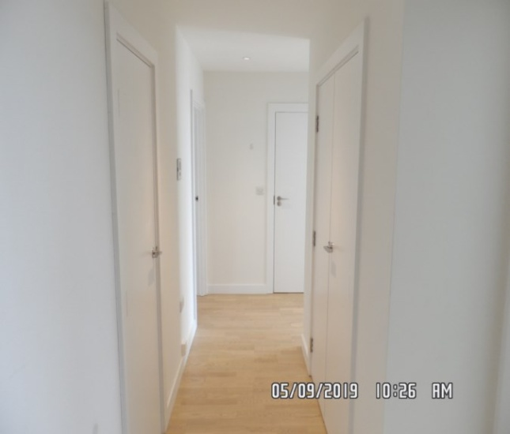

Entrance and hallway Entrance and hallway

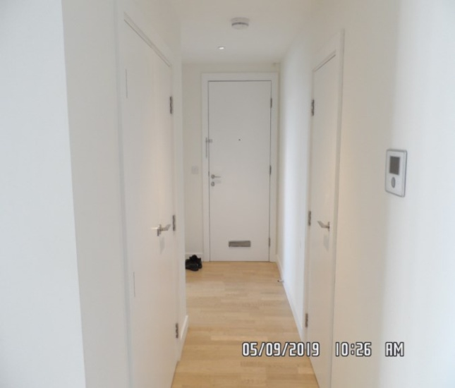 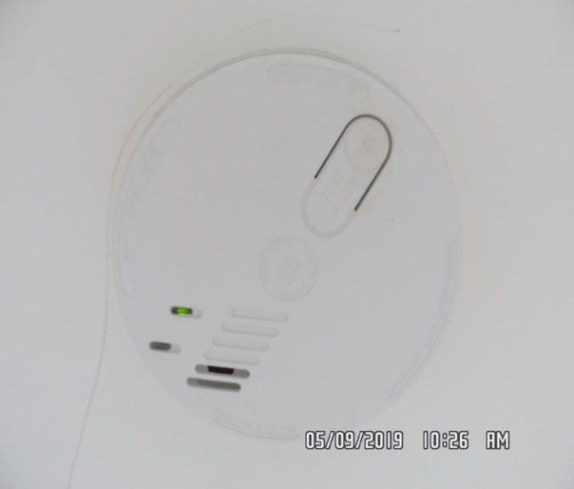

Entrance and hallway Entrance and hallway

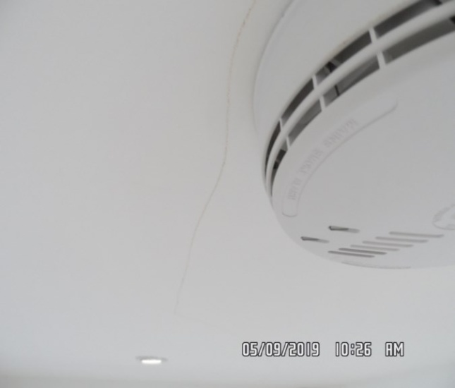 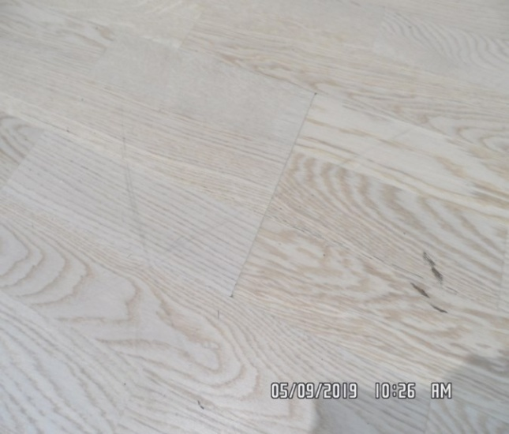

Entrance and hallway Entrance and hallway

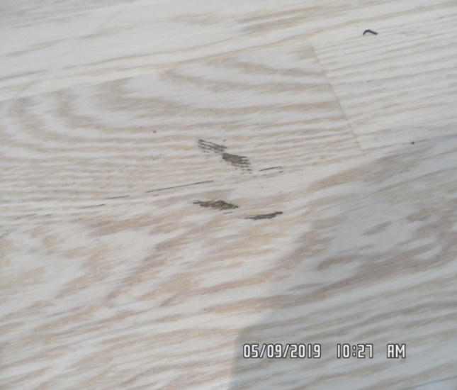 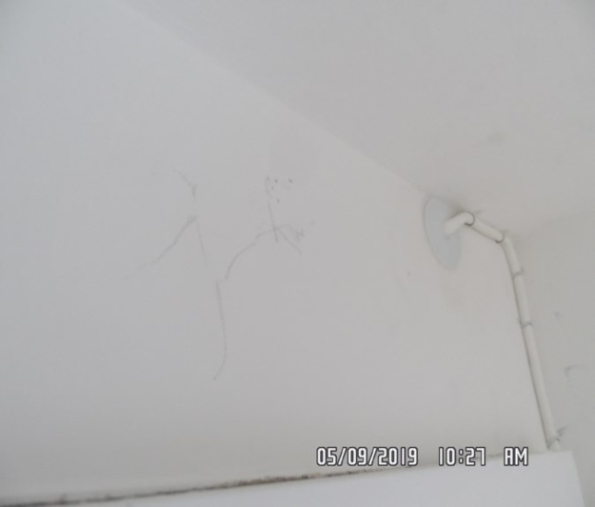

Entrance and hallway Entrance and hallway

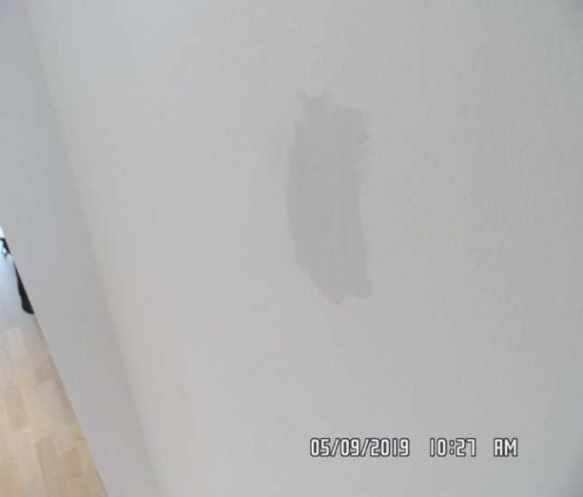 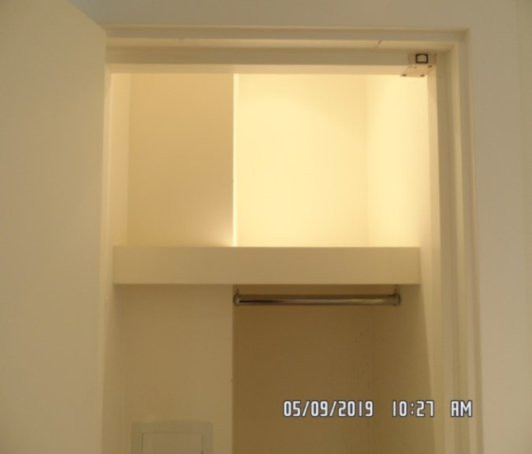

Entrance and hallway Entrance and hallway

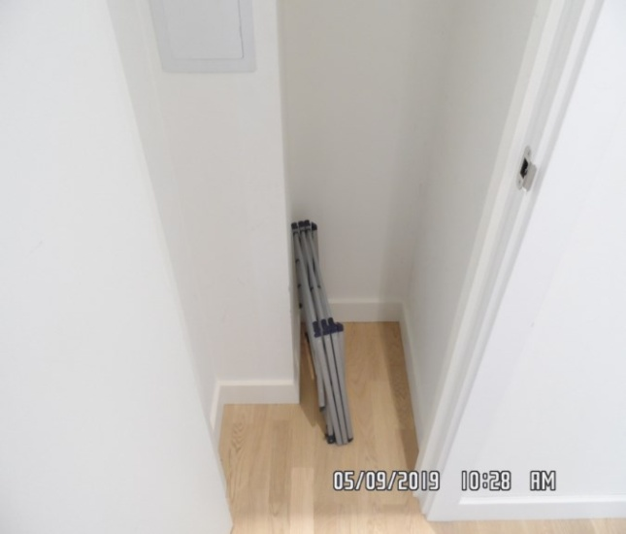 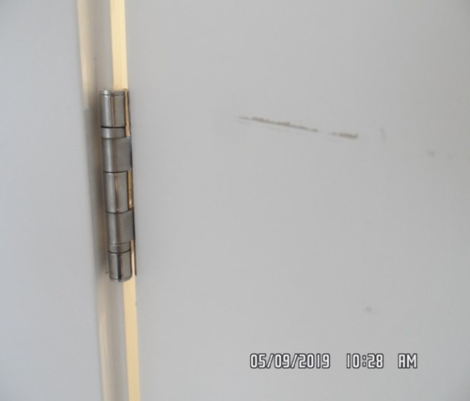

Entrance and hallway Entrance and hallway

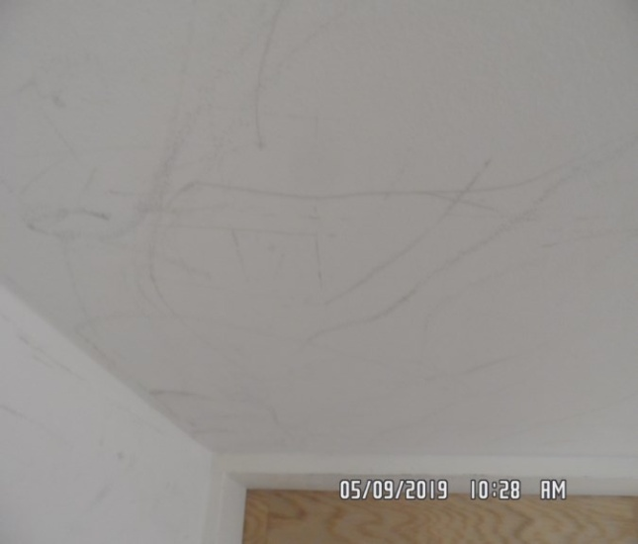 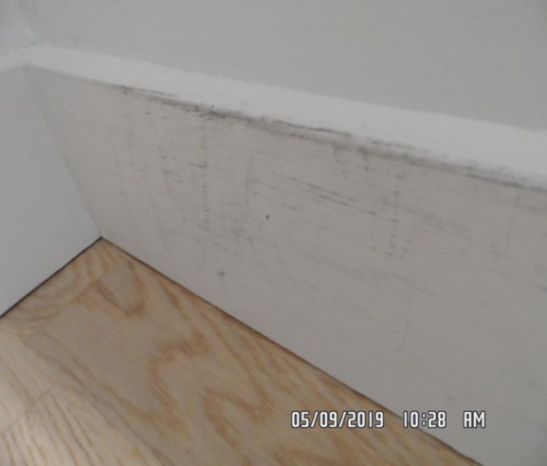

Entrance and hallway Entrance and hallway

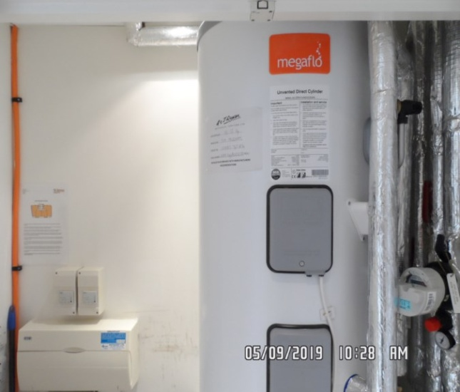 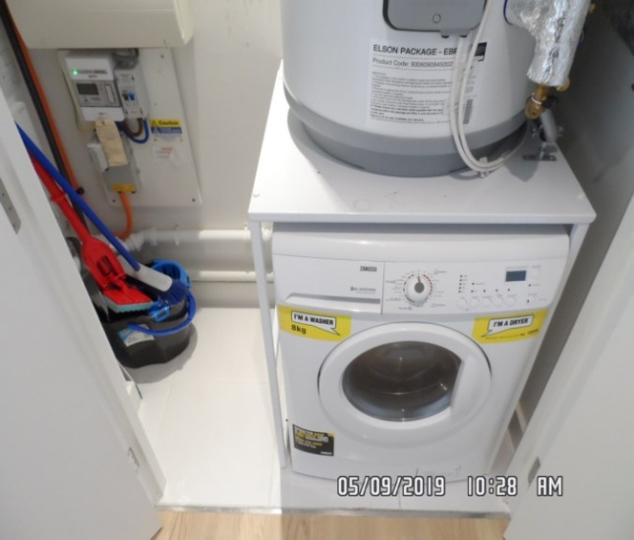

Entrance and hallway Entrance and hallway

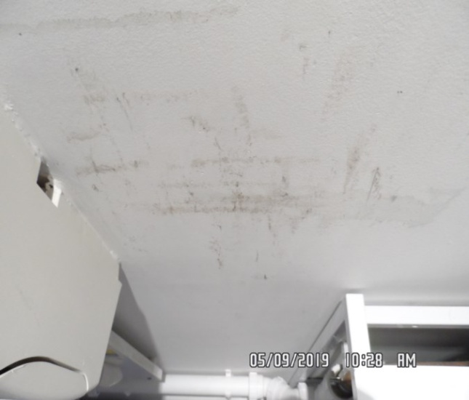 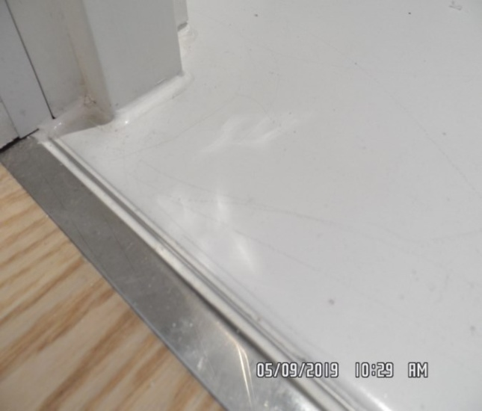

Entrance and hallway Entrance and hallway

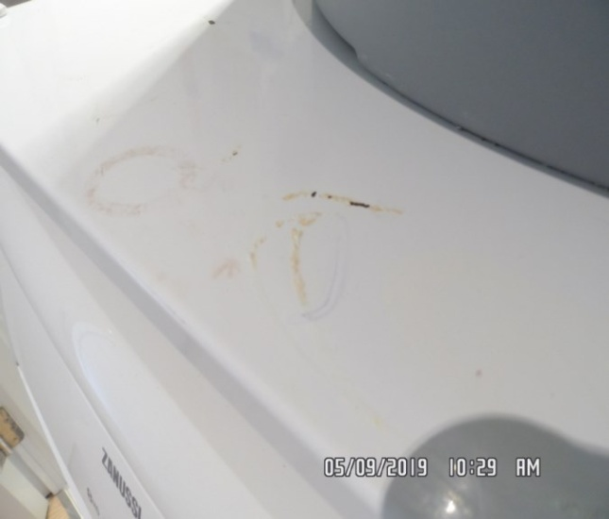 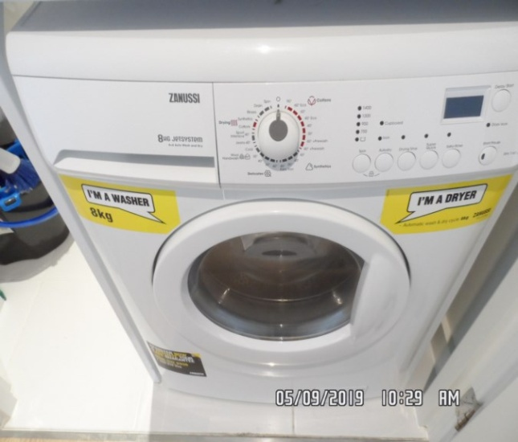

Entrance and hallway Entrance and hallway

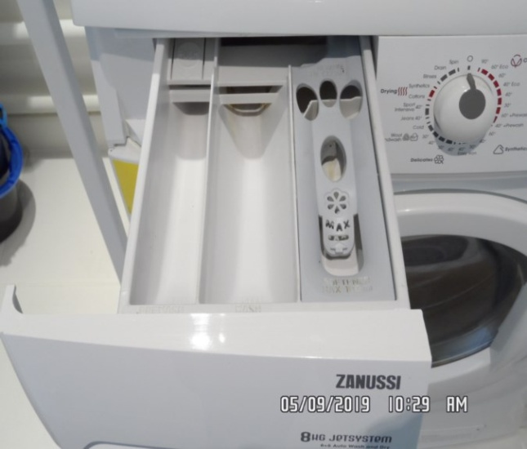 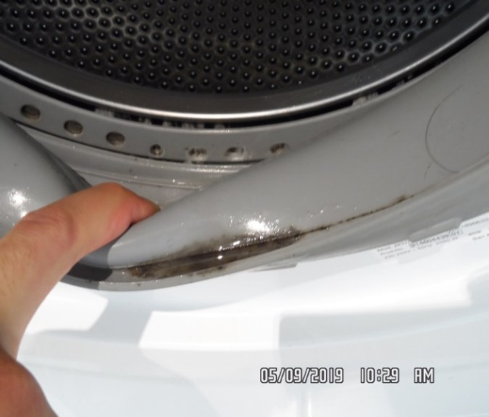

**CHECKOUT PHOTOGRAPHS**

**BEDROOM 1**

|  |  |  |  |
| --- | --- | --- | --- |
| **Door** | Painted white frame and door  Chrome twist handle | Good condition  Exterior frame 1 or 2 x light black scuffs left hand side mid level  1 x scuff seen to crossbar  Exterior door some light scratches near lever handle |  |
| **Interior** | Painted white frame and door  Chrome twist handle | Good condition  Interior door 1 or 2 x light scratches mid level  Some very faint black scuffing seen at high level |  |
| **Walls** | Painted white | Rear facing wall 2 x black hooks seen at mid level  Scattered scuff marks and rub marks at mid to low level  Further light scuffing seen to left and right hand side wall at high level |  |
| **Ceiling** | Painted white | Good condition  Heavy scuffing forward of wardrobe area |  |
| **Woodwork** | Painted white | Good condition  1 or 2 x light very minor scuff marks seen in places  Unable to fully inspect behind any furniture |  |

**BEDROOM 1**

|  |  |  |  |
| --- | --- | --- | --- |
| **Switches and sockets** | White plastic | Good condition  All intact |  |
| **Lighting** | 2 x recessed spot lights | Tested and working |  |
| **Flooring** | Light wood laminate | Showing light signs of usage and wear  Some light drag marks and light scuffing in places  Unable to fully inspect underneath any furniture  Currently in use |  |
| **Radiator** | Electric with fuse switch and digital display  Turn dials | Good order  Not tested  Appears to be intact |  |

**BEDROOM 1**

|  |  |  |  |
| --- | --- | --- | --- |
| **Fitted cupboards** | 2 x wooden sliding doors with integrated handles  1 x shelf  1 x chrome rail | Good condition  Walls to interior general scuffing seen from high to low level  Marks consistent with use  Door to interior 1 or 2 x light scuff marks in places  Unable to fully inspect to interior due to tenant items |  |
|  | Walls skirting and floor continuation of the bedroom | Good condition |  |
| **Window** | Wooden frame with double glazing  Chrome twist handle  Wooden sill  White plastic extractor vent integrated to the frame | Sealant to the edges in good order  Good condition throughout  Clean to interior  Soiled to exterior |  |
| **Blind** | Off-white roller blind with metal chain | Chain has breakers but no tidy visible  Good order  Appears to be in good used order |  |
| **Door stop** | Chrome and black rubber skirting mounted | Good condition  Intact |  |

**BEDROOM 1**

|  |  |  |  |
| --- | --- | --- | --- |
| **Bed** | 1 x black wooden laminate bed frame  White and grey mattress | 1. Currently fitted 2. Unable to fully inspect 3. Landlord has informed this is brand new |  |
| **Side table** | 1 x black wooden side table  2 x drawers with glass top | 1. Brand new |  |
| **Chest of drawers** | Black wooden laminate chest of drawers with 3 x drawers  Glass top to the top | 1. Brand new |  |
| **Bedside lamp** | 1 x stainless steel bedside lamp with white shade | 1. Tested and working for power |  |

Bedroom 1 Bedroom 1

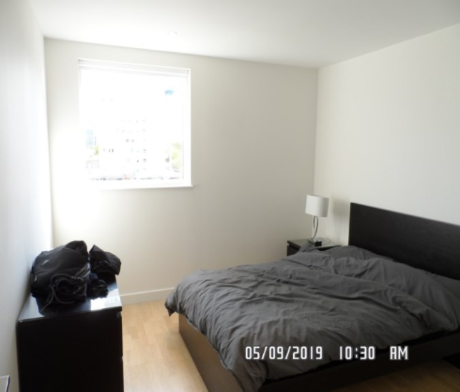 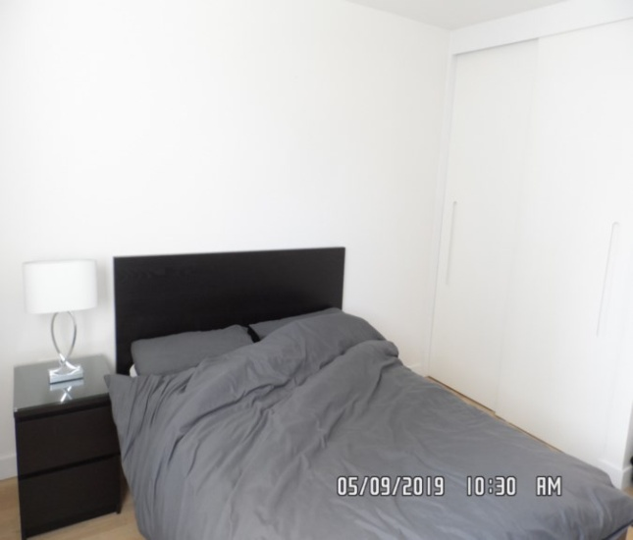

Bedroom 1 Bedroom 1

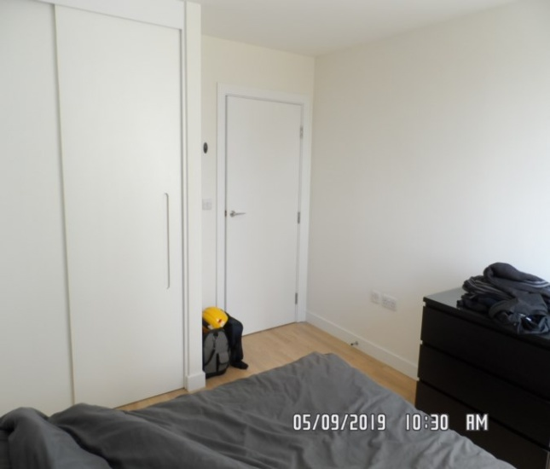 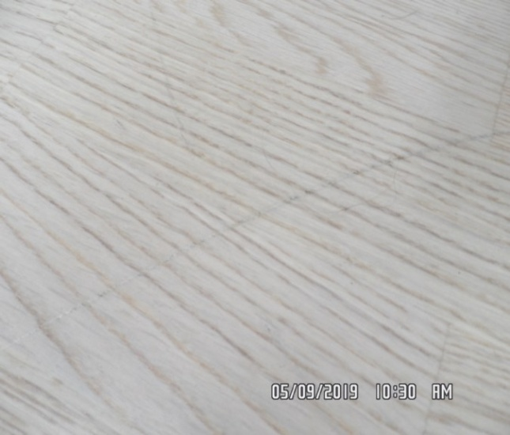

Bedroom 1 Bedroom 1

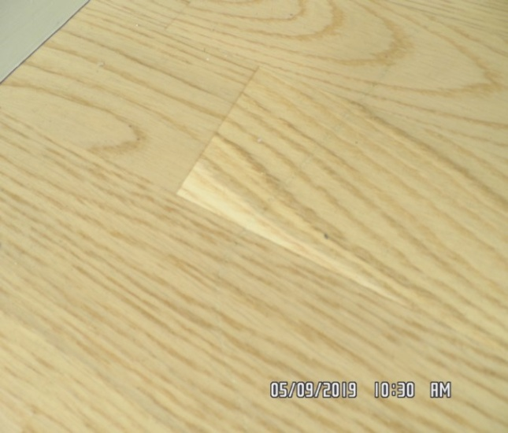 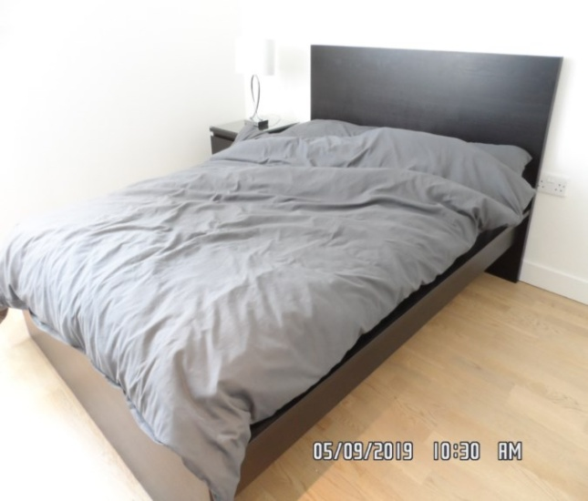

Bedroom 1 Bedroom 1

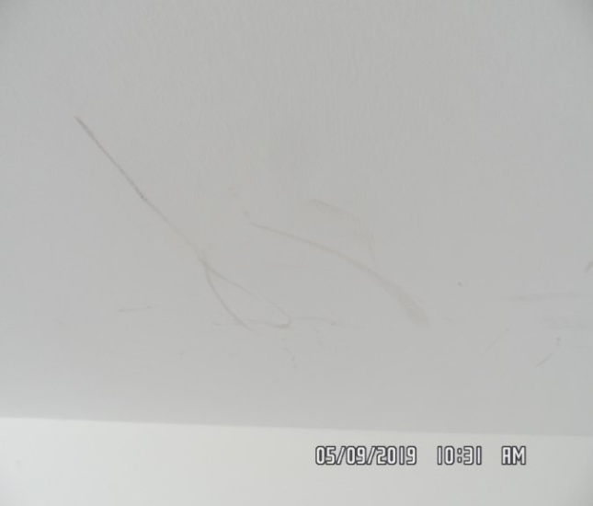 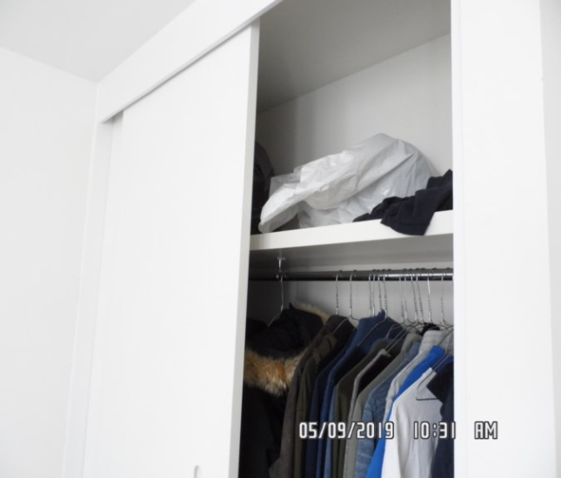

Bedroom 1 Bedroom 1

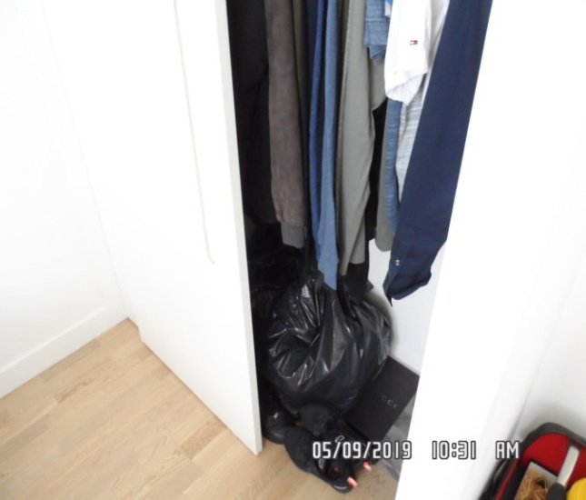 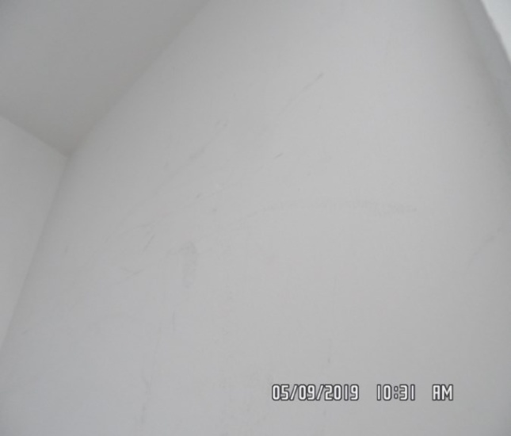

**CHECKOUT PHOTOGRAPHS**

**BEDROOM 2**

|  |  |  |  |
| --- | --- | --- | --- |
| **Door** | Painted white frame and door  Chrome twist handle | Small black mark to the left hand side bottom edge of the door |  |
| **Interior** | Painted white frame and door  Chrome twist handle | Good condition  Interior door black scuffing seen at high level |  |
| **Walls** | Painted white | Rear wall has a scratch above the plug socket 3-4”  Facing wall scratch mark left hand side of the radiator low level  Filler applied rear facing wall at high level  All walls showing light marks consistent with use light scuff marks and rub marks in places mid to low level  Some light chipping seen to the corner edges at an angle  Unable to fully inspect throughout due to contents |  |

**BEDROOM 2**

|  |  |  |  |
| --- | --- | --- | --- |
| **Ceiling** | Painted white | Good condition  Appears to be intact and in good order |  |
| **Lighting** | 3 x recessed spot lights | All tested and working for power |  |
| **Switches and sockets** | White plastic | Good condition  All intact |  |
| **Woodwork** | Painted white | Good condition  1 or 2 x light scuff marks seen |  |
| **Flooring** | Light wood laminate | Showing light signs of usage and wear  Some light scratches and drag marks in places  Unable to fully inspect throughout due to contents were visible  Some light debris in places |  |
| **Door stop** | Chrome and black rubber | Good condition  Intact |  |

**BEDROOM 2**

|  |  |  |  |
| --- | --- | --- | --- |
| **Fitted cupboards** | 2 x wooden doors with integrated handles  1 x shelf  1 x chrome rail | Good condition  Walls to interior general marks consistent with use from high to low level  Hat shelf unable to fully inspect due to height |  |
|  | Walls skirting and floor continuation of the bedroom |  |  |
| **Window** | Wooden frame x 4  2 x fixed panels  2 x opening  2 x chrome handles  Grey seals to the bottom edges  Wood painted white sill  White plastic extractor vent integrated to the frame | Few brown spot marks to the seal low level  Good condition  Glazing could benefit from final wipe to interior  Soiled to exterior  Sill some light scratches and rub marks in places  Some light smudge marks seen to glazing to interior  Lightly soiled to exterior  Sill and frame in places dust build-up visible |  |

**BEDROOM 2**

|  |  |  |  |
| --- | --- | --- | --- |
| **Radiator** | White metal electric with fuse switch and digital display  Turn dials | Good order  Not tested |  |
| **Blind** | Rohite vertical blinds with grey fabric  Plastic fittings  White metal track with chrome chain and white cords  Plastic tidy  Chain tidy and chain break seen | Chain has breakers but no tidy visible  In good used order  Appear to be intact and in good order |  |
| **Bed** | 1 x double size bed frame  White and grey mattress | 1. Unable to fully inspect to mattress as it is currently fitted 2. Frame appears to be intact and in good order |  |
| **Chest of drawers** | Black wooden laminate with glass top | 1. As noted by landlord brand new |  |
| **Chest of drawers** | 3 x drawers chest of drawers | 1. Unable to fully inspect due to tenant items |  |

Bedroom 2 Bedroom 2

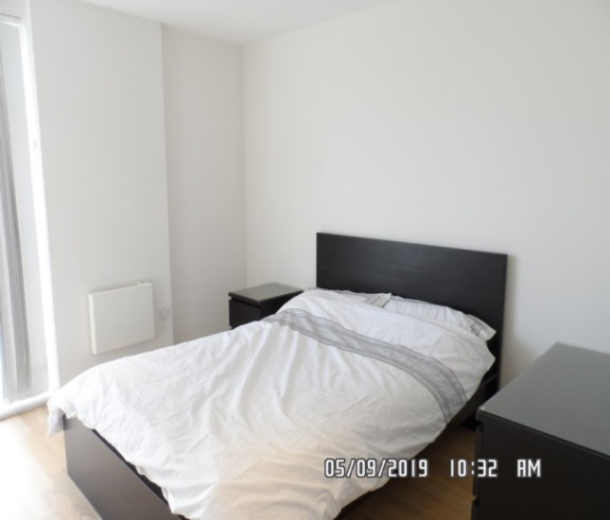 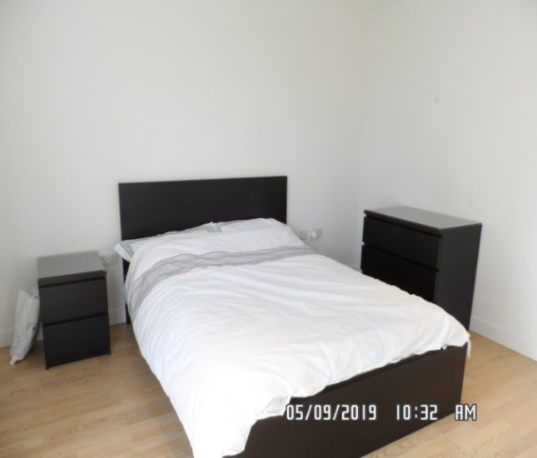

Bedroom 2 Bedroom 2

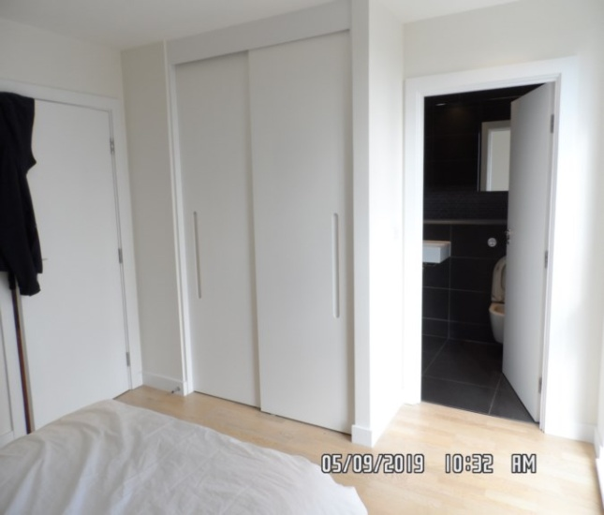 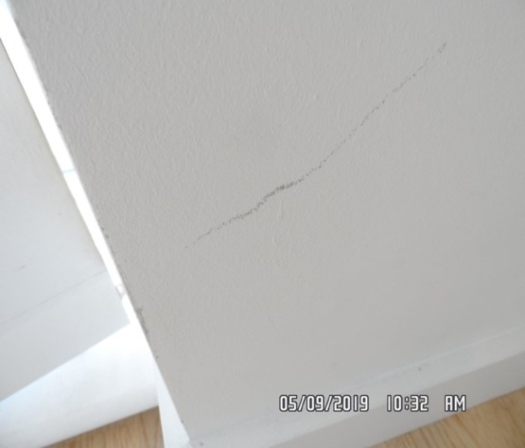

Bedroom 2 Bedroom 2

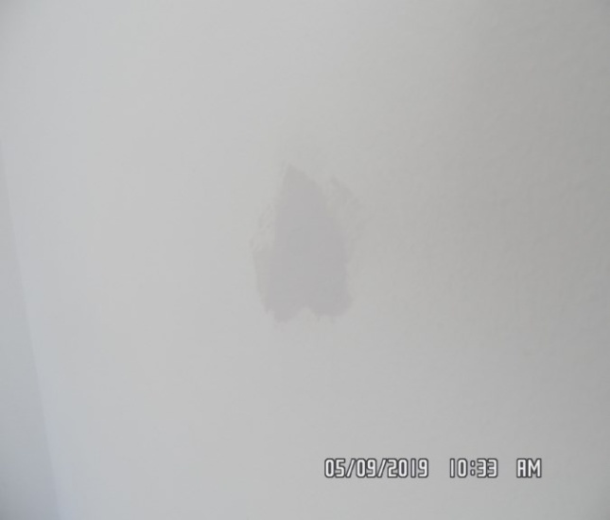 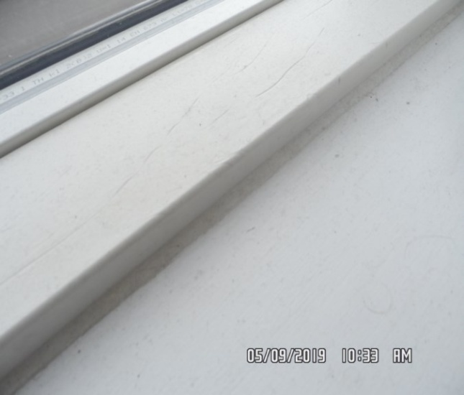

Bedroom 2 Bedroom 2

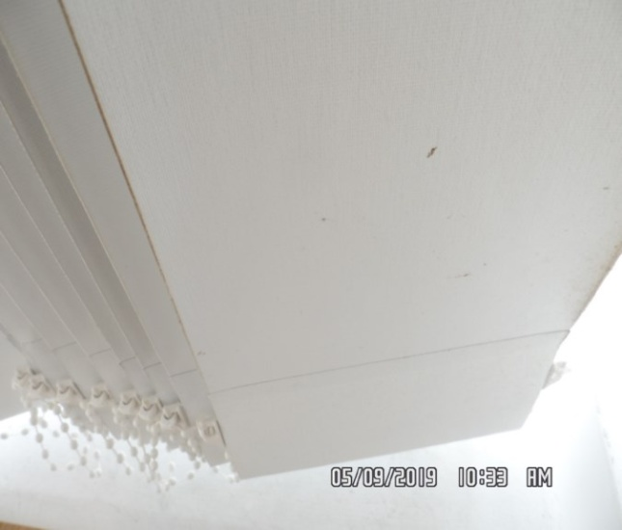 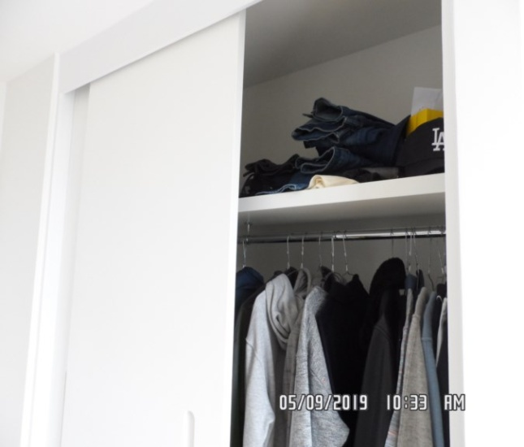

Bedroom 2 Bedroom 2

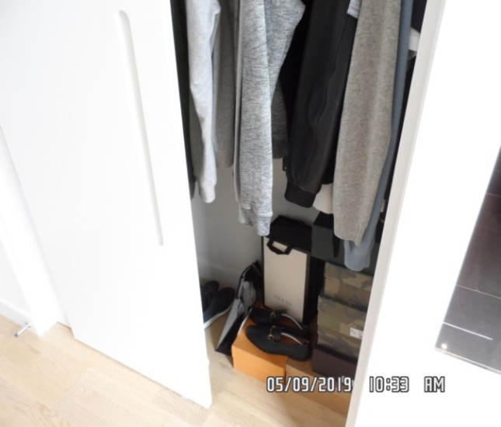 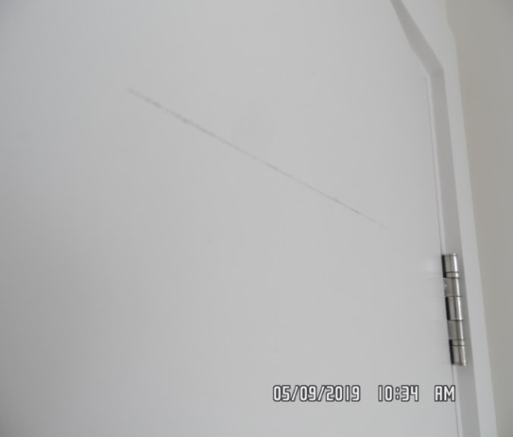

**CHECKOUT PHOTOGRAPHS**

**ENSUITE BATHROOM**

|  |  |  |  |
| --- | --- | --- | --- |
| **Door** | White painted door and frame  Chrome twist handle  Chrome integrated lock | Good condition  Light scuffing seen left hand side exterior frame at mid level  Exterior door appears to be intact and in good order  Exterior door 1 or 2 x light scuffs low level |  |
| **Interior** | White painted door and frame  Chrome twist handle  Chrome integrated lock  2 x chrome hooks | Good condition  Interior door and frame intact |  |
| **Walls** | Grey tiles with decorative tiles to the centre and grey grout | Good condition  All tiled sections appear to be intact and in good order  Some light white ingrained staining seen to tiles in shower cubicle area  Some light drip marks seen in places |  |
| **Ceiling** | Painted white | Good condition  Appears to be intact and in good order |  |

**ENSUITE BATHROOM**

|  |  |  |  |
| --- | --- | --- | --- |
| **Lighting** | 4 x recessed spot lights | Tested and working |  |
| **Extractor vent** | White plastic | Not tested |  |
| **Flooring** | Black tiles with grey grout | Small white mark to the right hand side corner  Lightly used condition  Some light scratches seen to the top surface  Discolouration seen to grout  Currently in use |  |
| **Splash back area and rear of toilet** | Continuation of the walls | Good condition  Appears to be in good order  Some drip marks seen in places |  |

**ENSUITE BATHROOM**

|  |  |  |  |
| --- | --- | --- | --- |
| **Medicine cabinet** | 2 x fixed panels to the left and right  2 x mirrored doors  2 x glass shelves  Interior:  chrome fittings  1 x shaving socket  Underfloor thermostatic control  4 x chrome hinges  2 x light strips to the top and bottom | Good condition  Lights tested and working  Clean to both interior and exterior  Currently in use |  |
| **Worktop** | Plastic composite with sealant to the edges | Good condition  Some white and purple ingrained staining scattered throughout |  |
| **Toilet** | Backed to wall white ceramic with enclosed cistern Villeroy and Boch  White plastic slow close seat and lid  Chrome flush wall mounted | Good condition  Showing power  Currently in use |  |
| **Basin** | Villeroy and Bosch  Chrome mixer tap  Chrome waste | Good condition clean  Showing power  Currently in use |  |

**ENSUITE BATHROOM**

|  |  |  |  |
| --- | --- | --- | --- |
| **Shower** | White plastic tray  White sealant to the edges  Chrome shower door with glass sliding door  1 x fixed panel  Chrome shower mixer controls  Chrome shower head with flexi hose  Chrome fixed shower head to the ceiling | Good condition throughout  Light white lime scale and light tarnishing to the bottom edge of the screen  Light marks to the waste  All in good order  Clean  Currently in use |  |
| **Towel rail** | Chrome | Good condition  Intact |  |
| **Toilet roll holder** | Chrome | Good condition  Intact |  |
| **Door stop** | Chrome and black rubber floor mounted | Good condition  Intact |  |

En-suite bathroom En-suite bathroom

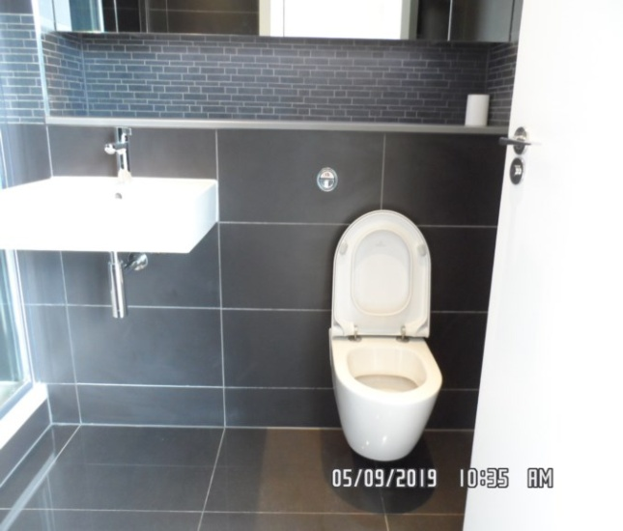 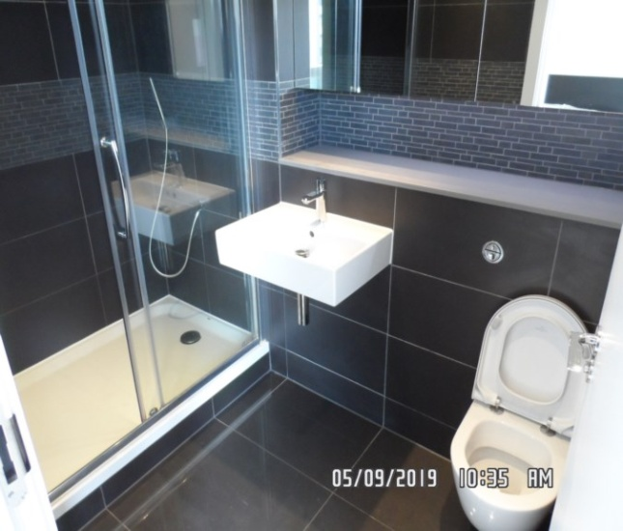

En-suite bathroom En-suite bathroom

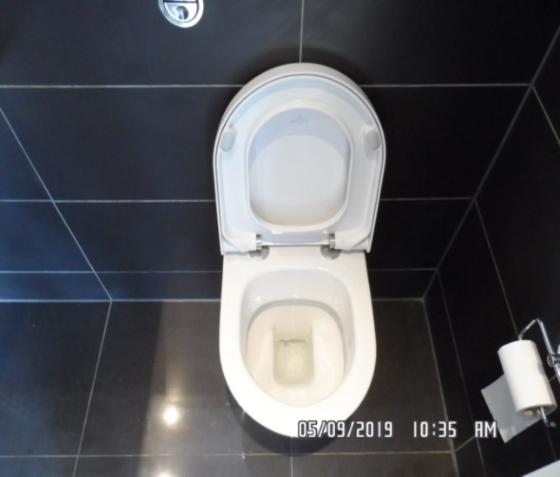 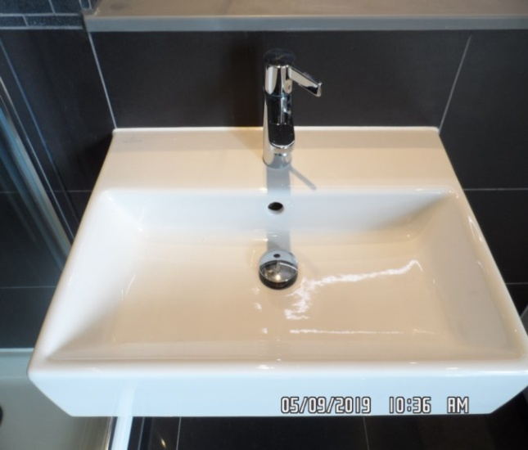

En-suite bathroom En-suite bathroom

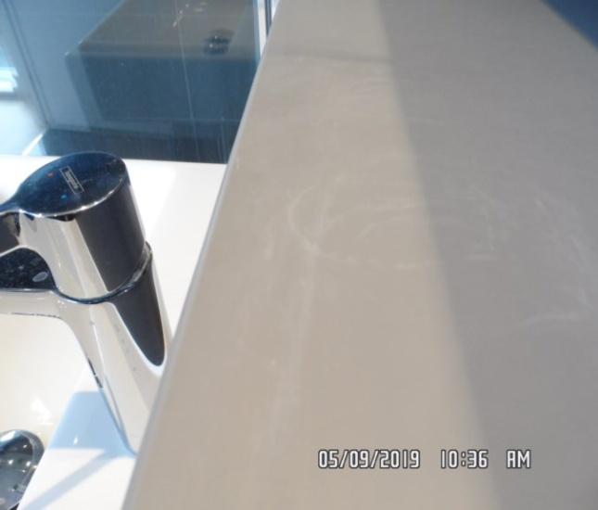 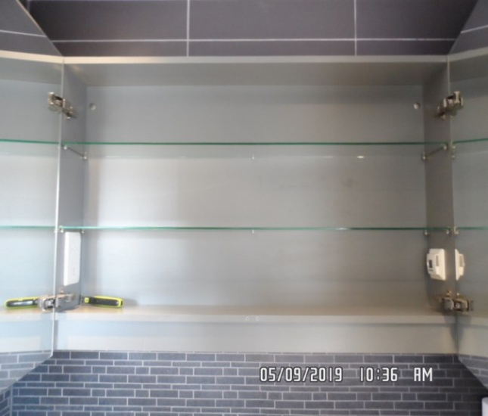

En-suite bathroom En-suite bathroom

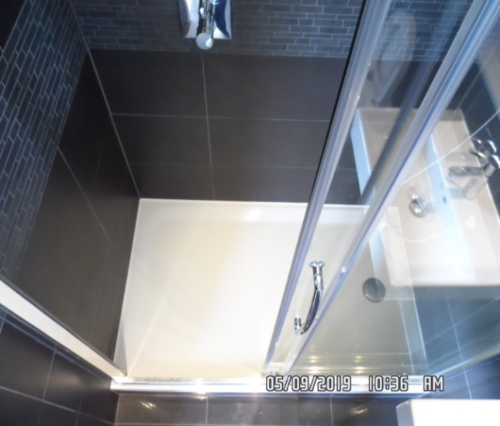 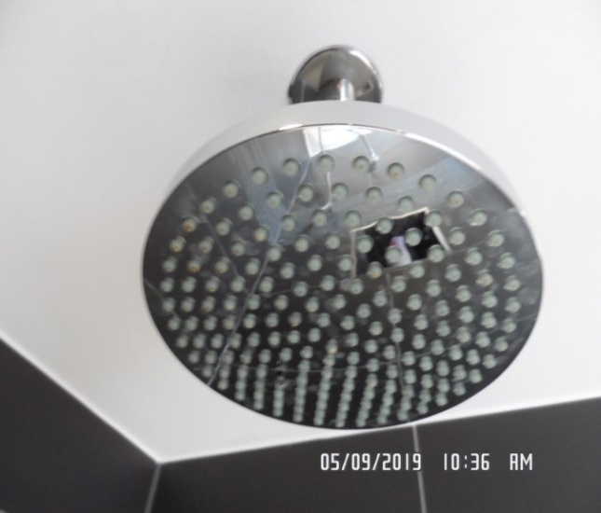

En-suite bathroom En-suite bathroom

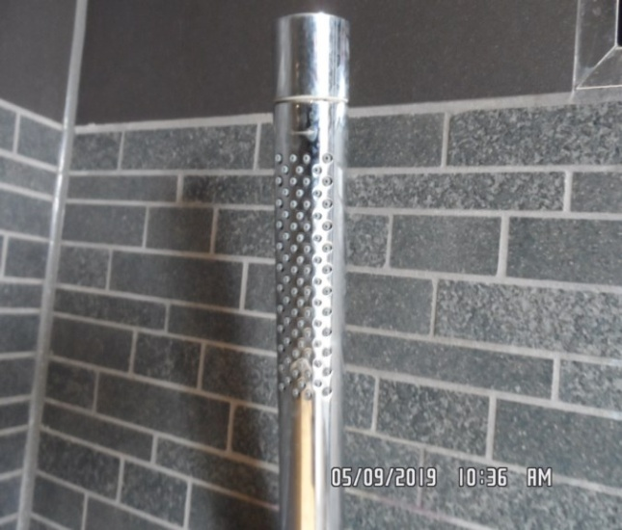 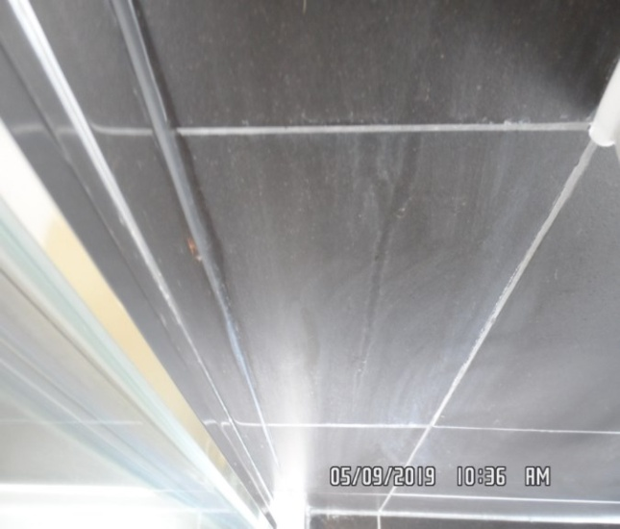

En-suite bathroom

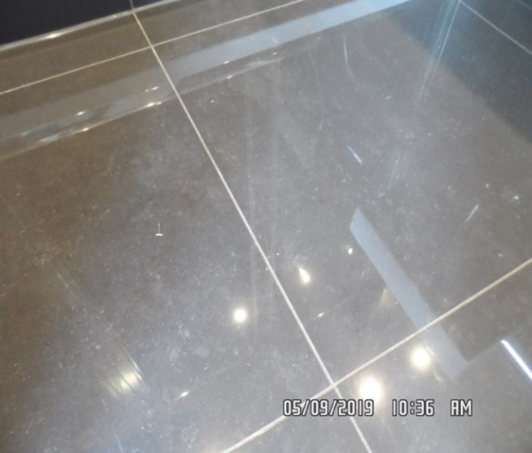

**CHECKOUT PHOTOGRAPHS**

**BATHROOM**

|  |  |  |  |
| --- | --- | --- | --- |
| **Door** | White painted door and frame  Chrome twist handle  Chrome integrated lock | Good condition  Exterior frame underside of crossbar black scuffing and chipping seen to the woodwork |  |
| **Interior** | White painted door and frame  Chrome twist handle  Chrome integrated lock  2 x chrome hooks | Good condition  Black scuffing at high level |  |
| **Walls** | Cream tiles with decorative tiles to the centre and cream grout  White towel holder right side of sink | Good condition  All tiled sections appear to be intact and in good order  Light discolouration seen to grout  1 x plastic hook seen to rear facing wall  Chrome hooks not seen |  |
| **Ceiling** | Painted white | Good condition  Appears to be intact and in good order  1 or 2 x light finger soil marks around recessed lights |  |

**BATHROOM**

|  |  |  |  |
| --- | --- | --- | --- |
| **Lighting** | 4 x recessed spot lights | All tested and working |  |
| **Extractor vent** | White plastic | Not tested  Some discolouration seen to underside  Further cleaning required |  |
| **Flooring** | Cream tiles with cream grout | Grout discoloured in some areas  General light signs of usage and wear |  |
| **Splash back area and rear of toilet and basin** | Continuation of the walls | Good condition |  |
| **Worktop** | White plastic composite with sealant to the edges | Good condition  Clean to the top surface  Currently in use |  |

**BATHROOM**

|  |  |  |  |
| --- | --- | --- | --- |
| **Medicine cabinet** | 2 x fixed panels  2 x mirrored doors  2 x glass shelves  Interior:  1 x shaving socket  Under floor thermostatic control  4 x chrome hinges  2 x light strips to the top and bottom | Good condition  Lights tested and working  Clean to both interior and exterior  Currently in use |  |
| **Toilet** | Backed to wall white ceramic with enclosed cistern Villeroy and Boch  White plastic slow close seat and lid  Chrome flush wall mounted | Good condition  Showing power  Seat and lid slightly loose  Currently in use |  |
| **Basin** | White ceramic Villeroy and Bosch  Chrome mixer tap  Chrome waste | Good condition  Clean to interior  Currently in use |  |
| **Towel rail** | Chrome | Good condition  Intact |  |
| **Toilet roll holder** | Chrome | Good condition  Intact |  |

**BATHROOM**

|  |  |  |  |
| --- | --- | --- | --- |
| **Bath** | White plastic composite bath  White sealant to the edges  Chrome spout  Chrome waste controls  Chrome waste  Chrome shower fittings  Fixed shower head ceiling mounted  Chrome shower head, flexi hose and fixed shower head  Glass shower screen with chrome fittings and seal to the bottom edge | bath and shower in good clean condition  All items clean  Sealant around the edges of the bath some light mould residue  Shower guard screen discolouration seen to the sealant  Currently in use |  |

Bathroom Bathroom

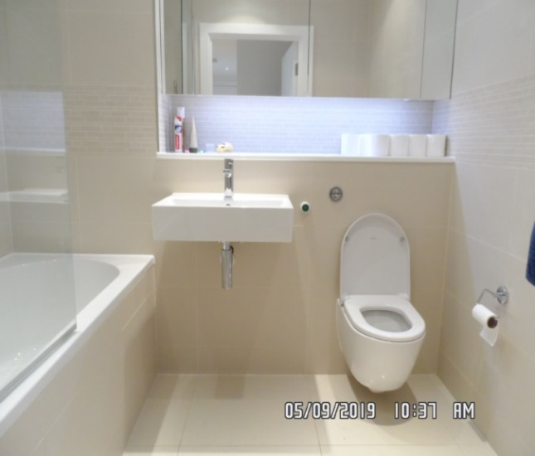 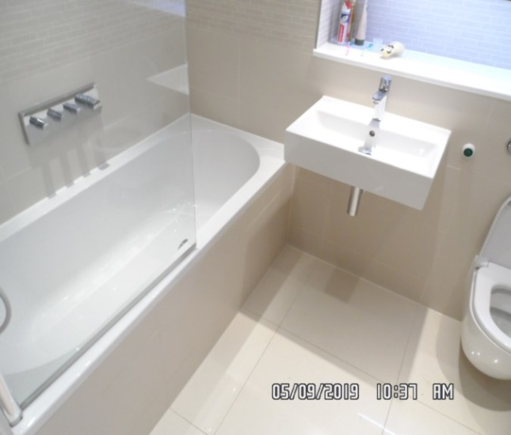

Toilet Basin

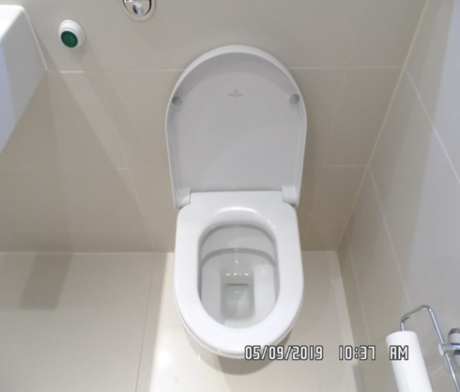 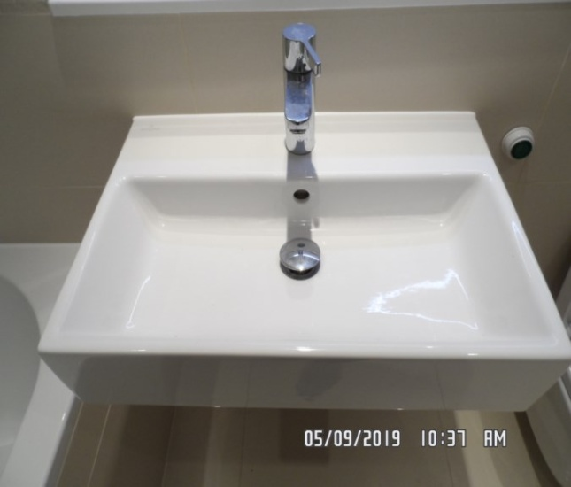

Bathroom Bathroom

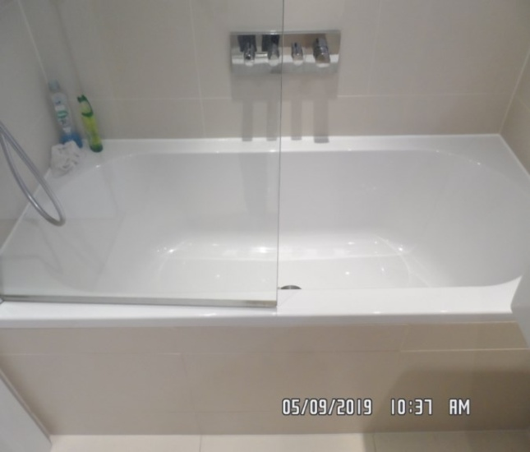 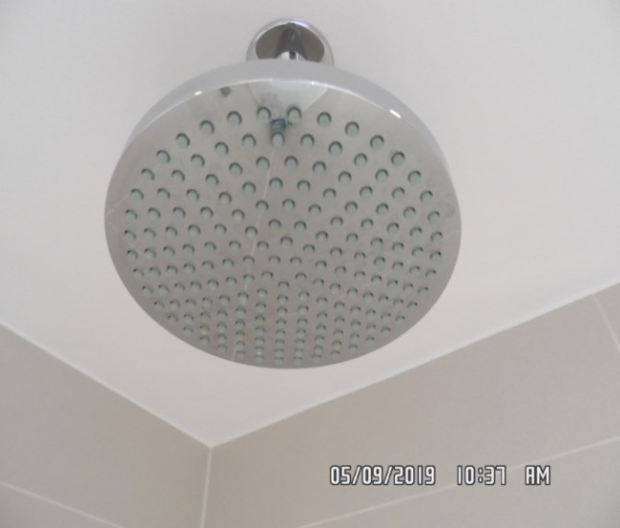

Bathroom Bathroom

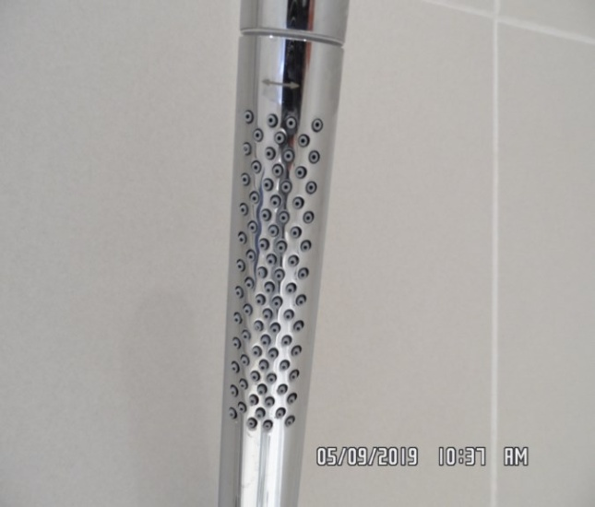 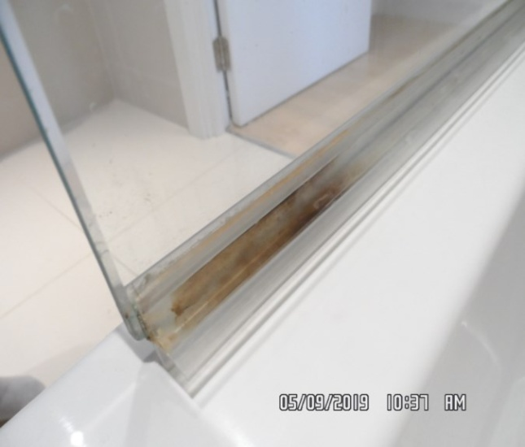

Bathroom Bathroom

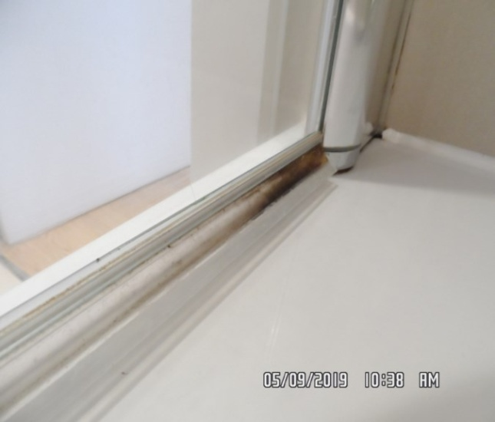 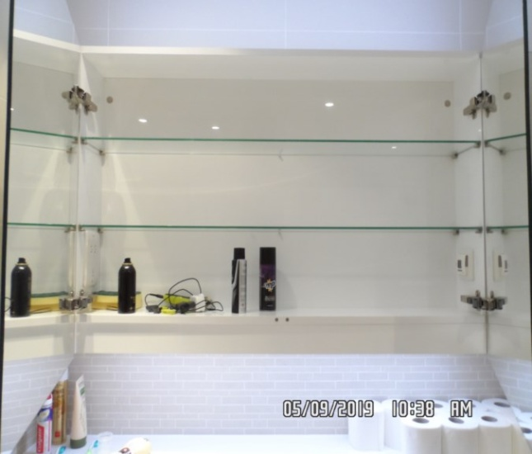

Bathroom

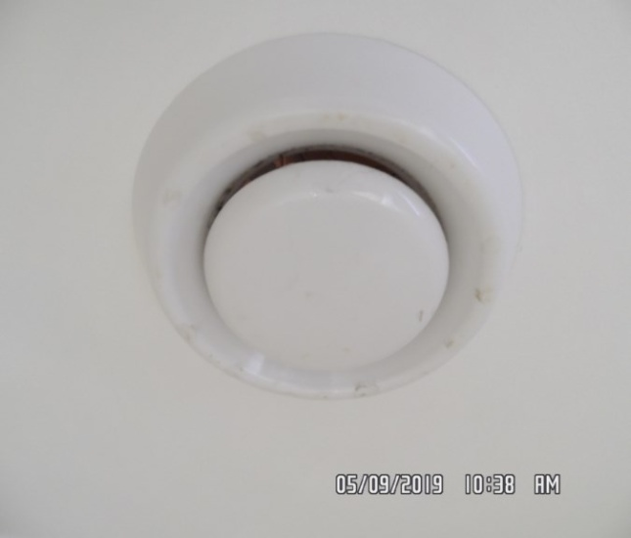

**CHECKOUT PHOTOGRAPHS**

**RECEPTION**

|  |  |  |  |
| --- | --- | --- | --- |
| **Door** | Painted white door and frame  Chrome twist handle | Scratch mark to the door centre 1/2”  Good order  Exterior door frame bottom right hand side 1 x chip  Exterior door 1 or 2 x black scuff marks seen in places  Exterior door some finger soil marks seen mid level |  |
| **Interior** | Painted white door and frame  Chrome twist handle | Yellow paint mark to the bottom edge of the door  Interior door some light very minor chipping seen to the bottom edge at an angle |  |
| **Walls** | Painted white | Rear wall has some minor rub marks – very feint to low level  Right hand side wall 3 or 4 rubs to the centre low level  Light scuffing seen right hand side at low level  Rear facing wall near kitchen 2 x filler sections  Scattered drip marks at mid level  Splashback appears to be clean to the top surface  Not inspected behind any furniture |  |

**RECEPTION**

|  |  |  |  |
| --- | --- | --- | --- |
| **Ceiling** | Painted white | Good condition  Some yellow shading above kitchen units grease staining |  |
| **Lighting** | 9 x recessed spot lights | All tested and working |  |
| **Vent** | Air conditioning vent white plastic | Good condition  Appears to be intact  Not tested |  |
| **Switches and sockets** | Chrome and white plastic socket board | Good condition  All appears to be intact |  |
| **Woodwork** | Painted white | 1 or 2 x light rub marks seen in places |  |
| **Flooring** | Light wood laminate | Showing light signs of usage and wear  Currently in use |  |
| **Heat alarm** | White plastic | Green light seen  Tested for power |  |

**RECEPTION**

|  |  |  |  |
| --- | --- | --- | --- |
| **Radiator** | White metal electric with fuse switch and digital display  Associated buttons | Good condition  Appears to have 1 or 2 x light scuffs  Not tested    Unable to fully inspect as sofa forward radiator |  |
| **Windows** | White wooden frame double glazed  2 x fixed windows  2 x opening sliding doors with 3 chrome handles  Wooden sill painted white  Brushed steel threshold to low level  Double glazed and integrated air vents to the left side of the frame | Sealant slightly cracking to the right hand side mid level  Good clean order to the interior  Frames in good order  Clean to both interior and exterior  Frame appears to be in good order  Glazing appears to be clean to both interior and exterior |  |
| **Curtains / blinds** | White metal track  Fabric vertical curtains with plastic fittings to low level in white  Chrome chain, white fabric cord and plastic fitting wall mounted | Breaker not seen  Tidy in good order  Chain break and chain tidy present  Blinds appear to be in good used order |  |

**RECEPTION**

|  |  |  |  |
| --- | --- | --- | --- |
| **Door stop** | Chrome and black rubber skirting mounted | Good condition  Intact |  |
| **Sofa** | Dark grey 2-seater sofa  2 x seater cushions and 2 x rear cushions  Foot stool | 1. Landlord has informed to clerk all brand new |  |
| **TV display unit** | 3-tier TV display unit  Glass with silver frame | 1. Landlord has informed to clerk all brand new |  |
| **Dining table** | 1 x frosted glass top dining table  Stainless steel legs  4 x white moulded plastic chairs with stainless steel legs | 1. All brand new as informed by landlord |  |

Reception Reception

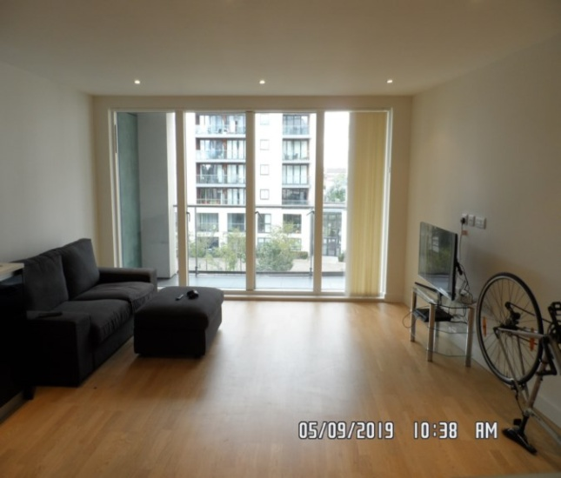 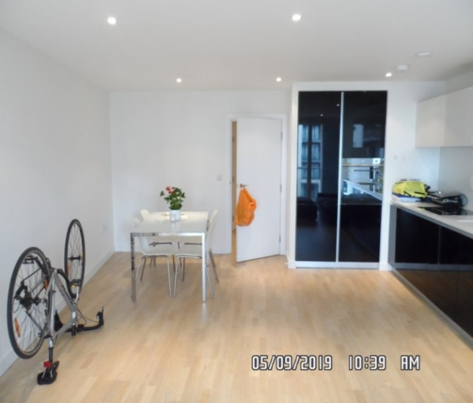

Reception Reception

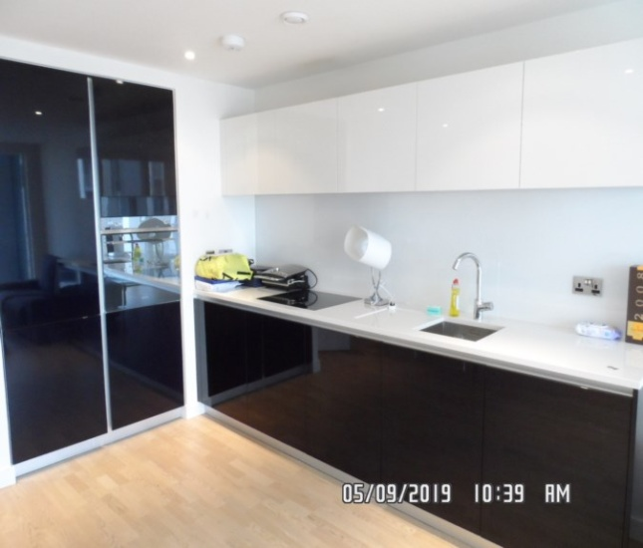 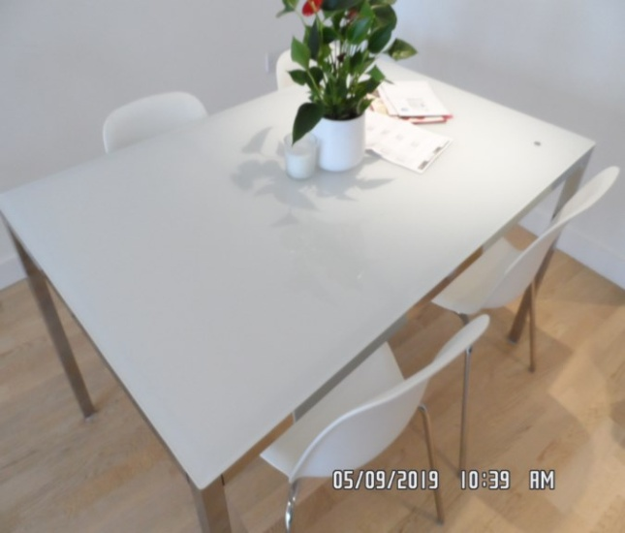

Reception Reception

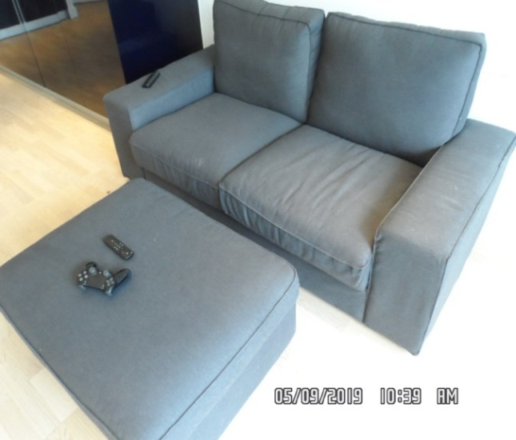 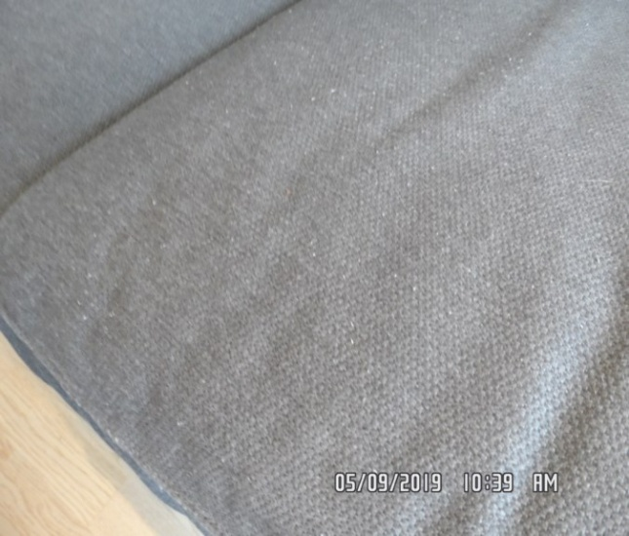

Reception Reception

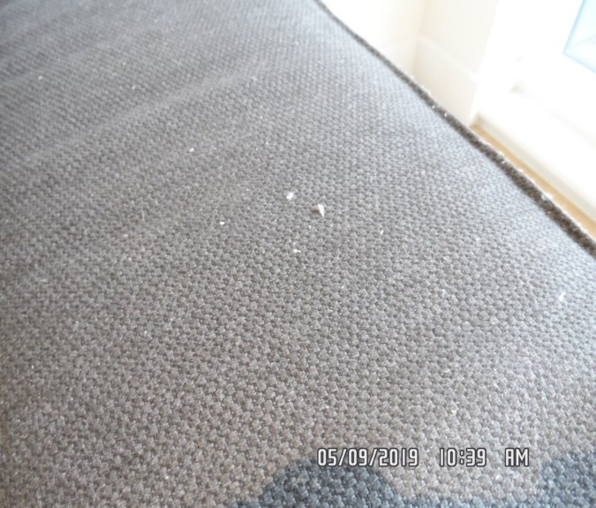 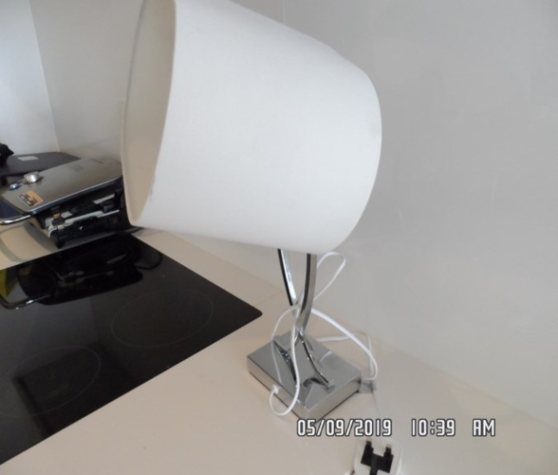

Reception

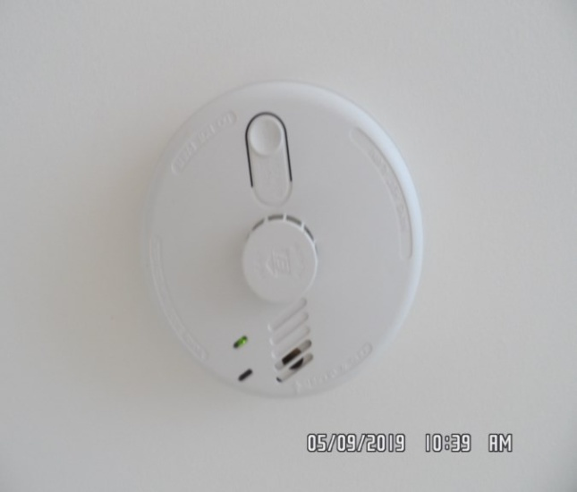

**CHECKOUT PHOTOGRAPHS**

**OPEN PLAN KITCHEN**

|  |  |  |  |
| --- | --- | --- | --- |
| **Units** | White gloss laminate doors  Black laminate gloss doors  Grey laminate interior and shelves  Chrome hinges – slow close to interior | No handles  Some light debris seen to interior  All units appear to be in good clean order  Currently in use |  |
| **Tall unit 1** | Tall unit double door integrated fridge/freezer Zanussi  Serial no: 50400191  2 x salad crispers  5 x dairy shelves  1 x light  Temperature control  4 x door trays  3 x freezer compartments | 1 x freezer compartment to the centre is cracked to the front fascia  Lightly used condition  Water drips to the shelves and to the rear  1 or 2 x stain marks seen to bottom door shelves  Further clean required  Crack to drawers noted  Currently in use  Heavy ice build-up to freezer |  |
| **Tall unit 2** | Single door to high level  1 x shelf  Single door to low level  1 x shelf | Good condition |  |
| **Oven** | Smeg oven  Serial no: 5021011391  2 x chrome racks  1 x grey baking tray  Glass door with chrome and grey metal handle  Digital display  2 x turn dials | Good condition and clean  Clean to both interior and exterior  Some drip marks seen to interior and exterior viewing glass  Some white residue along the edges of the door frame |  |

**KITCHEN**

|  |  |  |  |
| --- | --- | --- | --- |
| **Wall unit 1** | Single door  1 x shelf  Rubber mat visible to the shelf | Good condition |  |
| **Wall unit 2** | Single door  Fuse switch  Extractor fan | Good condition |  |
| **Wall unit 3** | Single door  1 x shelf  Rubber mat visible to the shelf | Good condition |  |
| **Wall unit 4** | Single door  1 x shelf  Rubber mat visible to the shelf | Good condition |  |
| **Wall unit 5** | Single door  1 x shelf | Good condition |  |
| **Base unit 1** | Single door  3 x metal shelves  Rubber mat visible to the shelf | Good condition  All base units to exterior showing some light chipping seen to the laminate  Some faint scratches seen to the doors in places |  |

**KITCHEN**

|  |  |  |  |
| --- | --- | --- | --- |
| **Base unit 2** | Single door  1 x shelf  Rubber mat visible to the shelf | Good condition |  |
| **Base unit 3** | Zanussi integrated dishwasher  Serial no: 50653368  2 x grey metal racks  1 x grey plastic cutlery tray | Showing power  Good clean order |  |
| **Base unit 4** | Single door  1 x grey plastic bin  Under sink plumbing | Good condition  Light signs of usage and wear |  |
| **Base unit 5** | Single door  1 x shelf  Rubber mat visible to the shelf | Good condition |  |
| **Kickboards** | Stainless steel effect laminate | Good condition  Some light scuff marks and rub marks in places  In use |  |
| **Splashback** | Glass | Good condition  Appears to be intact and in good order  In use |  |

**KITCHEN**

|  |  |  |  |
| --- | --- | --- | --- |
| **Extractor fan** | Grey plastic integrated Electrolux  2 x lights  2 x filters | Filters heavily greasy  Fan tested and working  1 x light currently showing power  Grease build-up seen to the filters to the underside  Extractor fan rattling noise when turned on  Currently in use |  |
| **Hob** | Smeg ceramic touch button | Tarnishing around the left hand side bottom burner and right hand side top burner  Clean to the top surface  Cleaning scratches seen in places  Currently in use |  |
| **Worktop** | White stone with drainer area  Cut out for sink area | Good condition  Light discolouration seen to the joints  Currently in use |  |
| **Sink** | Stainless steel rectangular  1 x chrome mixer tap  1 x chrome waste | Heavy scratch marks to the base  Tap in good clean condition  Showing power  Currently in use |  |

**KITCHEN**

|  |  |  |  |
| --- | --- | --- | --- |
| **Manuals** | St James Home Development pack with associated appliance manuals, Guides and Usage of the Development  1x window key for terrace received by concierge  Grey folder of manuals |  |  |

Fridge/ freezer Fridge/ freezer

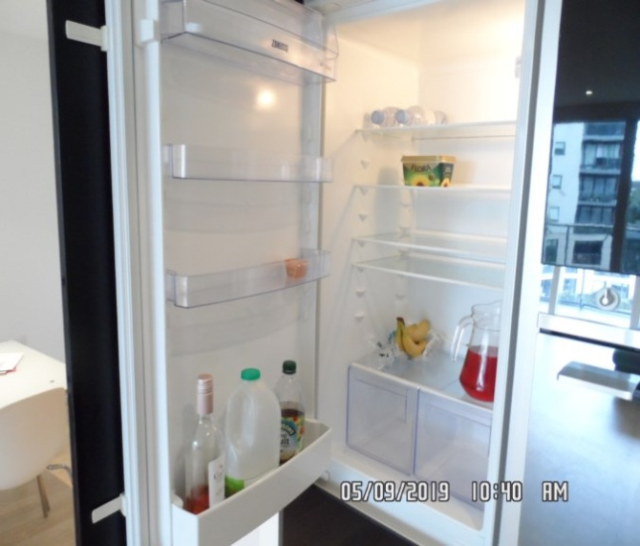 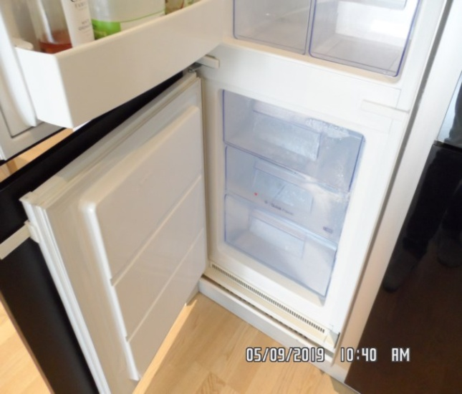

Fridge/ freezer Oven

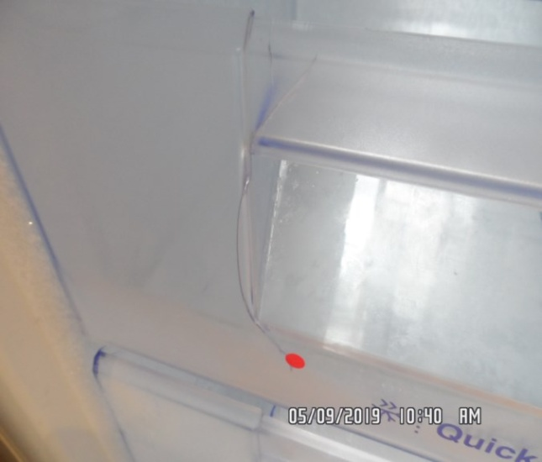 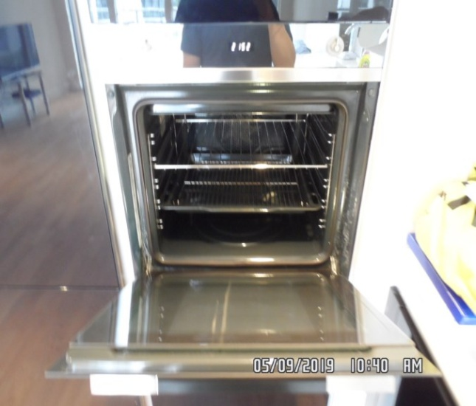

Oven Oven

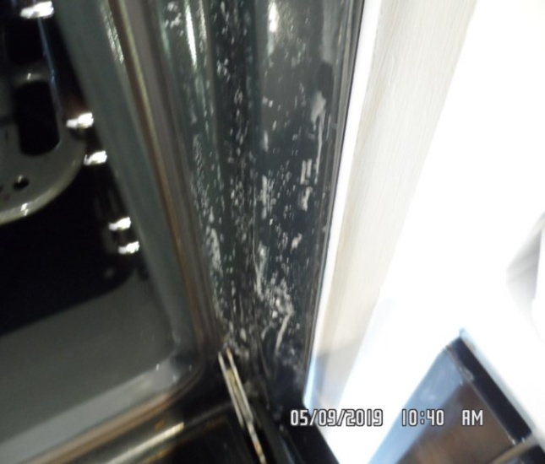 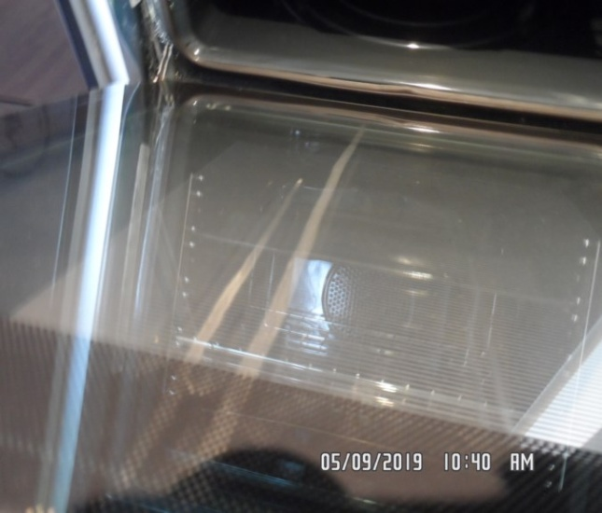

Extractor Hob

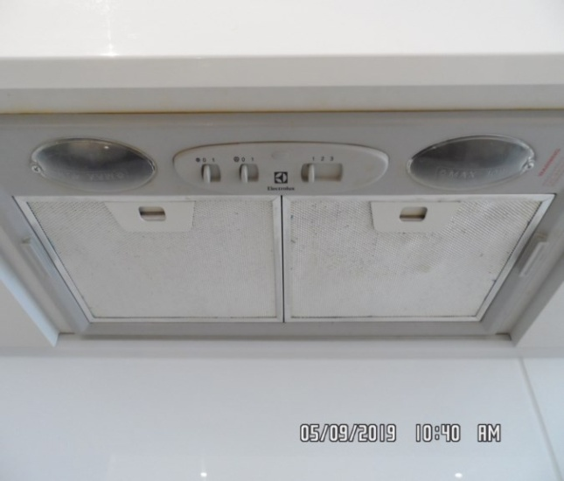 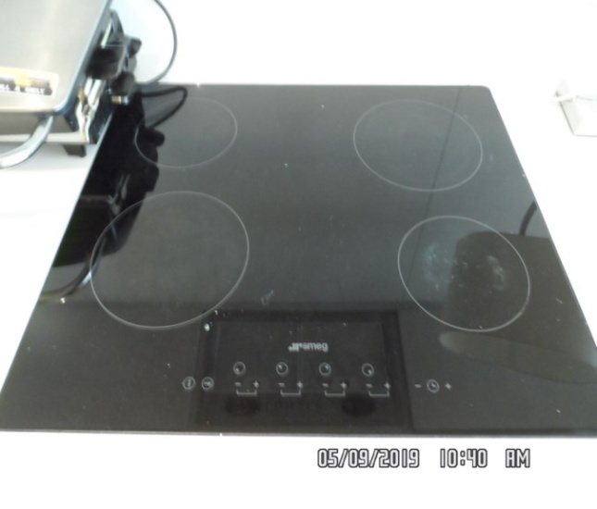

Hob Dishwasher

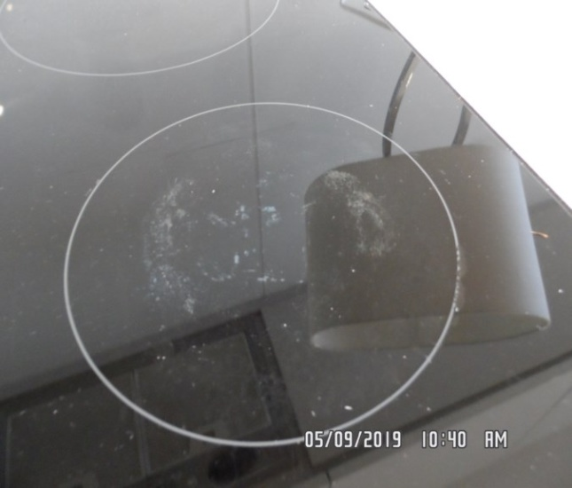 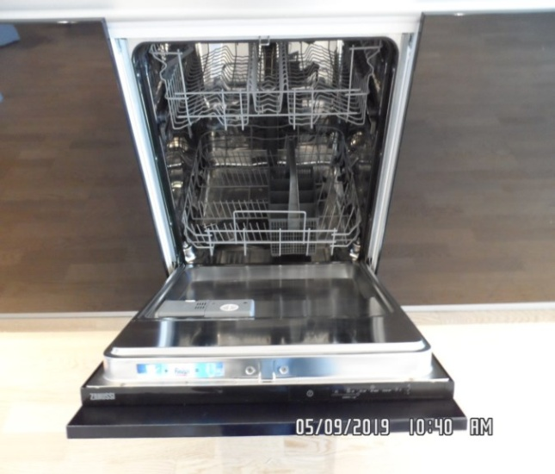

Sink Kitchen

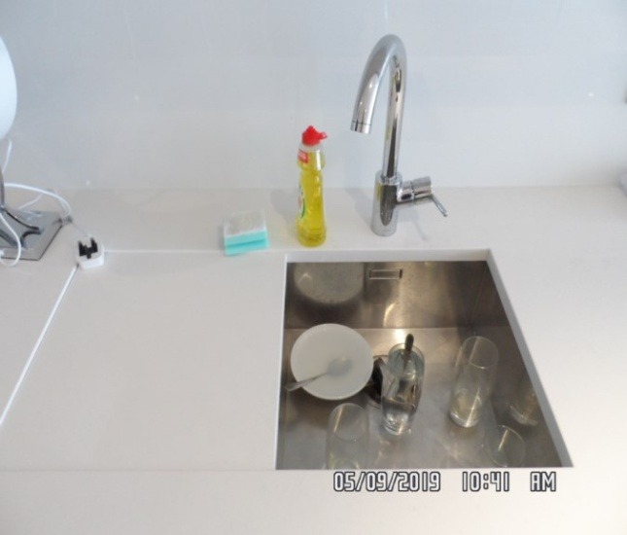 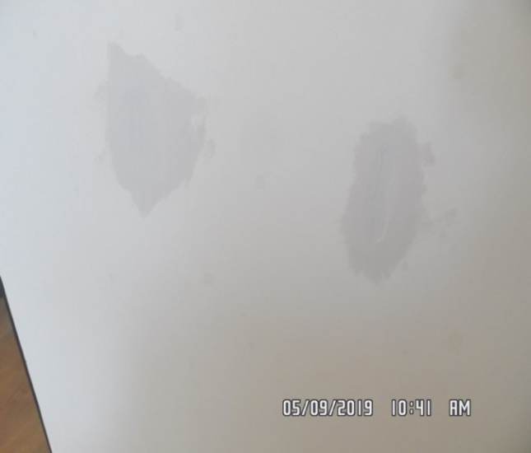

Kitchen Kitchen

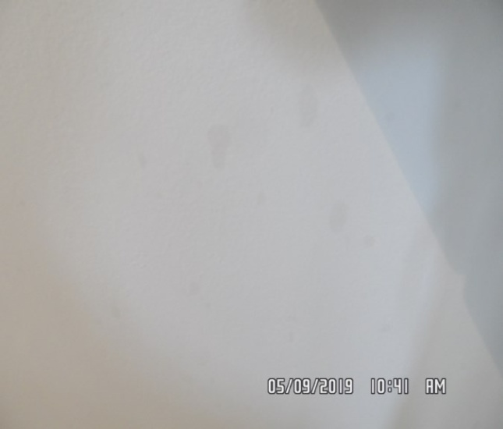 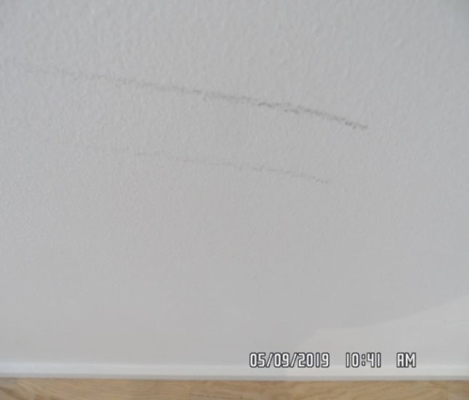

Kitchen Kitchen

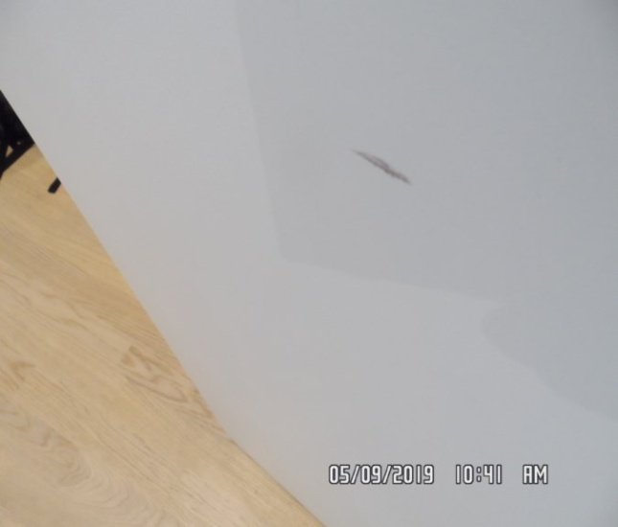 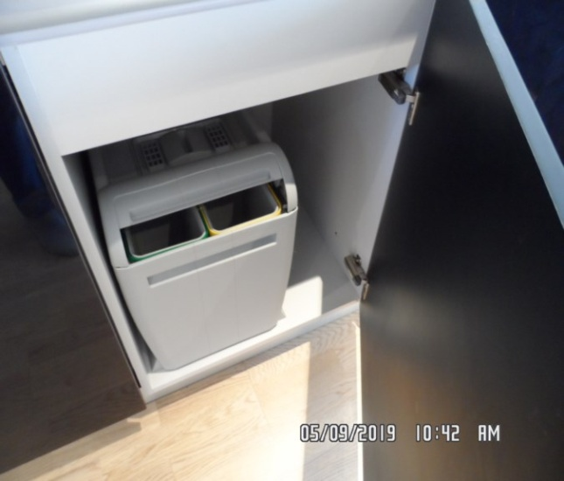

Kitchen Kitchen

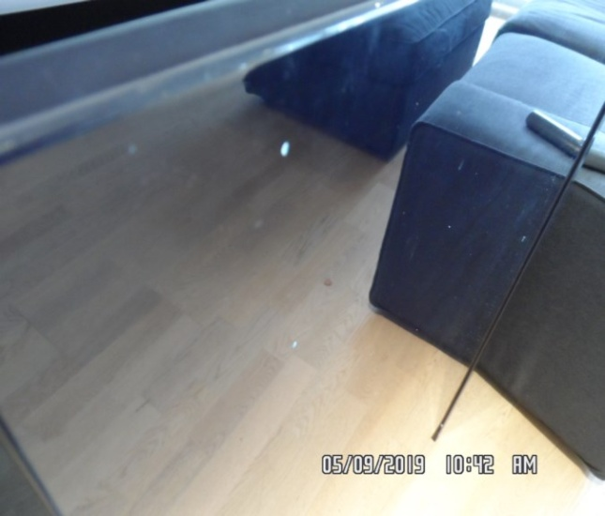 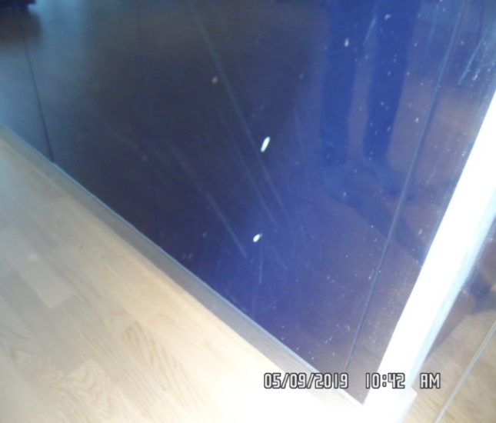

Kitchen Kitchen

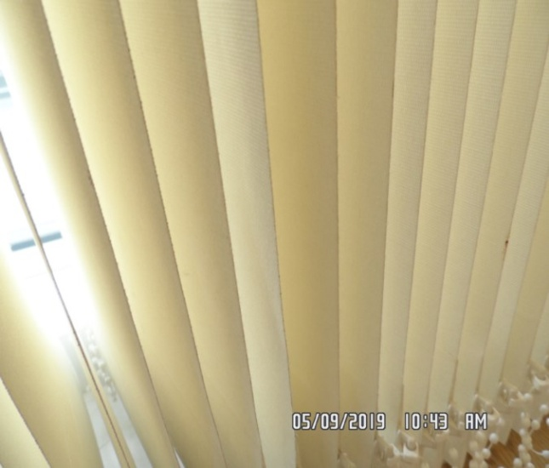 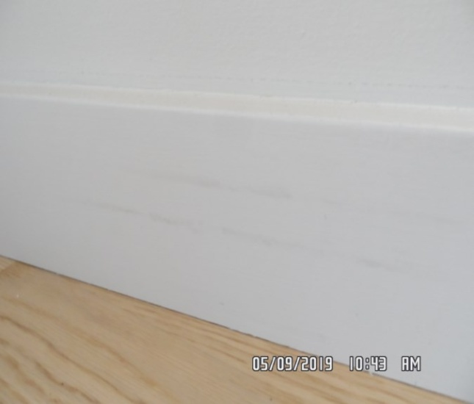

**CHECKOUT PHOTOGRAPHS**

**TERRACE**

|  |  |  |  |
| --- | --- | --- | --- |
| **Wall** | Green plaster panelling  White rendered plaster | Good condition  Weathered condition  Some light weathering seen in places |  |
| **Ceiling** | Aertex plaster | Good condition |  |
| **Flooring** | Grey tile with grey grout | Some general weathering throughout  White ingrained staining and light scratches seen in places  2 x tiles with hairline crack forward of rail area |  |
| **Rails** | Glass panels with grey metal frame with circular chrome handle | Light weathering to exterior  Brushed stainless steel section weathering seen  Glass panels appear to be clean |  |

Terrace Terrace

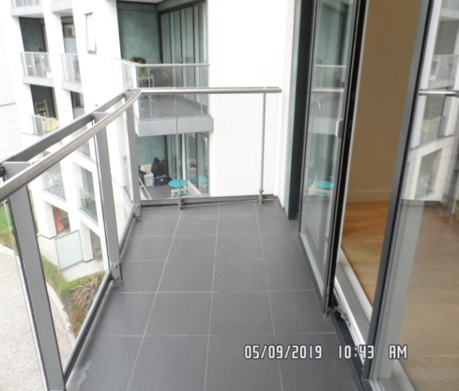 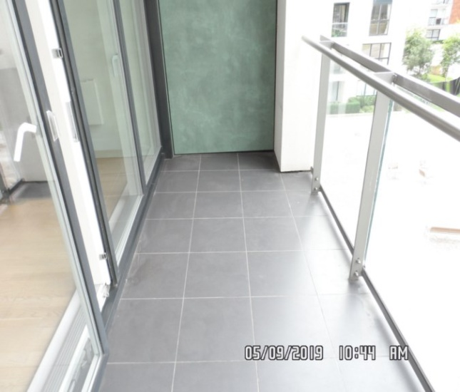

Terrace Terrace

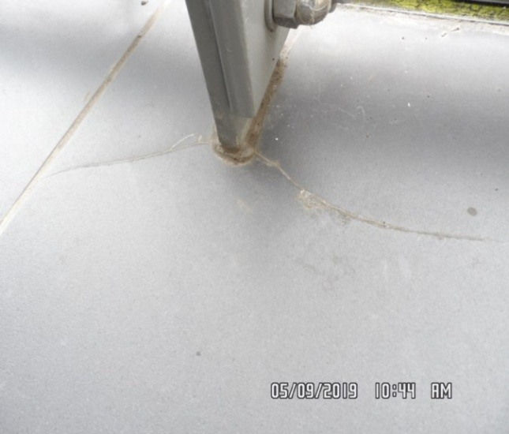 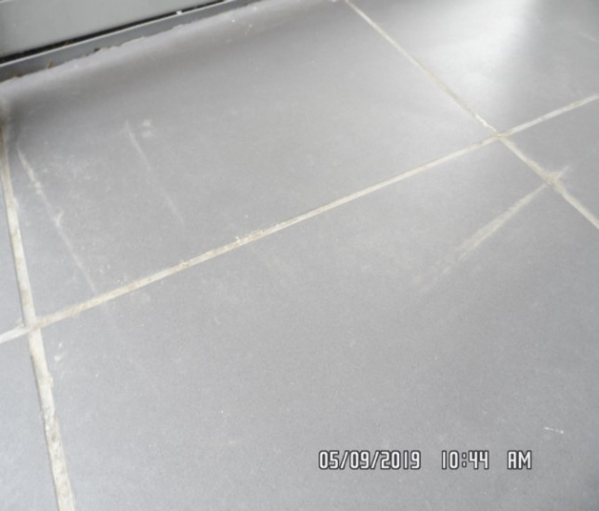

Terrace

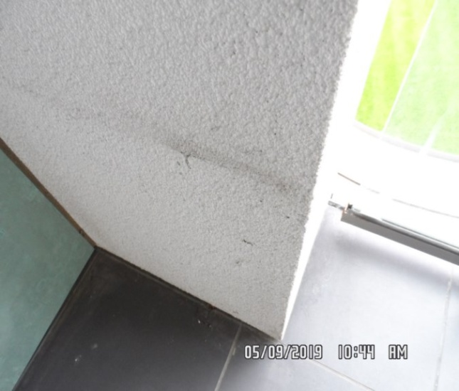

**CHECKOUT PHOTOGRAPHS**













   